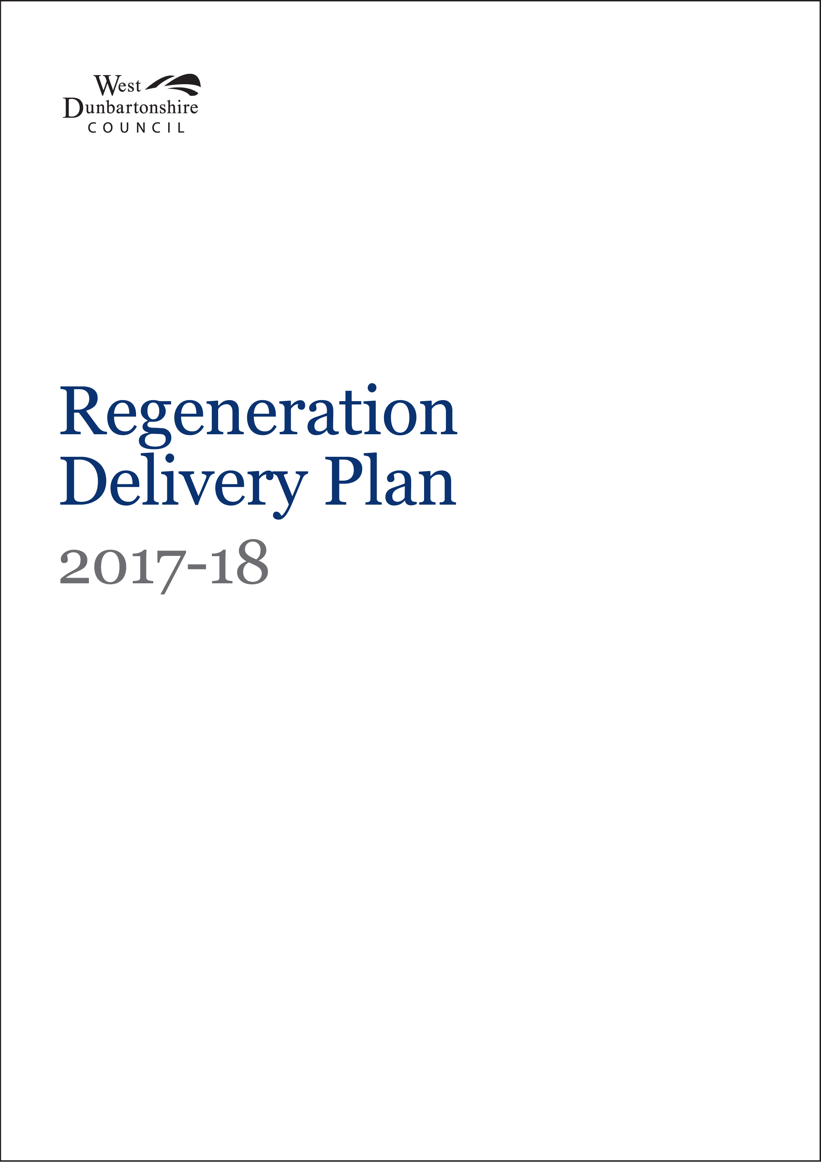

Index
1. Overview and Profile 2
2. Strategic Assessment 12
3. Resources 17
4. Risks 19

Appendix 1 – Regeneration Structure Chart 20
Appendix 2 - Action Plan 2017-18 21
Appendix 3: Performance Indicators 2017-18 23
Appendix 4: Workforce Plan 2017-18 24

Overview and Profile

The Regeneration Strategic area plays a major role in stimulating economic growth within West Dunbartonshire. The division is responsible for the Council’s assets (housing and non- housing), delivery of all Housing repairs and maintenance, delivering the Council’s General Services and Housing Revenue Capital Plans. In addition, the division delivers all repairs and maintenance to our housing tenants. Economic Development support and driving regeneration activity in the area is also a divisional responsibility.

The Regeneration Delivery Plan provides a review of our key achievements in 2016/17, sets out our strategic priorities for 2017/18, and highlights the key activities that will be progressed to meet those priorities. Regeneration is one of 8 strategic service areas within the Council, responsible for 5 distinct service areas: Economic Development; Corporate Asset Management; Capital Investment; Building Services and Housing Capital Investment Programme.

Regeneration and Business Support
The Service has responsibility for a range of strategic regeneration initiatives and for contributing to the sustainable economic growth of West Dunbartonshire. Economic Development comprises of two service areas, Business Support and Regeneration. The focus of the Business Support service is to provide business advice and support through a range of discretionary grants, loans and bespoke business support interventions offering flexible assistance to local businesses, including the delivery of Business Gateway. The overall objective is to increase employment and to help create sustainable economic growth within the local economy. The Regeneration Service focus is on the unlocking of key strategic sites of both the Council and others to create the opportunity to secure economic growth through regeneration.

Corporate Asset Management
Corporate Asset Management comprises of four operational sections: Consultancy Services, Energy & Compliance, Assets & Estates and PPP Contract Monitoring.

- Consultancy Services is the Council’s in-house construction consultancy, designing, managing and/or supporting client department construction related projects with a combined value of over £30m this year
- The Energy & Compliance Section ensures the effective provision of energy services and the Councils response to the climate change agenda by way of a comprehensive sustainability, carbon reduction and energy management regime. The section also manages the Councils responsibilities in relation to Strategic Environmental Assessments. Compliance is a key component of this team and will include compliance development and monitoring in areas such as asbestos, legionnella etc.
- The Assets & Estate Team contributes and supports the effective management of all council assets e.g. operational and non-operational buildings, Council owned assets requiring disposal and asset valuations. The team have direct responsibility for the asset management of all operational and non operational properties and sites and supporting the school estate. This now also includes the Clydebank Property Company, which the Council took over in 2014.
- The PPP Contract Monitoring Section takes the lead in all contractual dealings with the Special Purpose Vehicle (SPV)/PPP Contractor and the in-house services delivered by the Authority in effectively managing the Project Agreement to protect the Council’s best interests and ensure best value is achieved.

Capital Investment Team
The Capital Investment Team was set up to deliver the Council’s key strategic capital projects. The team are in Year 3 of the programme to deliver £200m worth of capital projects and work with operational management to bring these new facilities into operation. These projects include; 2 Care Homes, Kilpatrick ASN School, O.L.S.P, Bellsmyre Co-location, Office Rationalisation Programme, Depot Rationalisation Programme, Wind Farm and Clydebank Leisure Centre, additional Primary School in Balloch, supporting Queens Quay and the City Deal funded project at Exxon, Bowling . The team will ensure projects are delivered on programme and ensure effective budgetary control.

Building Services
Building Services provides a wide range of services for the local communities, clients and customers. It provides committed repairs and maintenance services which are customer focused through a range of professional, technical and front line services.

The section is responsible for:

- The delivery of an effective and efficient response repairs and planned works service to council houses and public buildings (including a 24 hour emergency service); serving a range of in-house clients, housing associations and the Leisure Trust
- Managing service contracts to ensure maintenance of gas installations, lifts etc.
- Providing an extensive building construction apprentice employment programme covering a range of crafts
- Working in partnership with the West Dunbartonshire Tenants and Residents Association (WDTRO) to carry out Tenant Priority Works and Planned Maintenance Programmes
- Growing Building Services and making it more commercial in coming years by entering in to shared services and providing services to Local Registered Social Landlord, National Park and other Public Funded Agencies.

Housing Asset & Investment
Housing Asset and Investment comprises four main service areas: Housing Capital Investment, Disability Adaptations, Sold Property Administration and Private Housing Grants.

- Managing Housing Capital Investment to ensure compliance with the Scottish Housing Quality Standard (SHQS), the Energy Efficiency Standard for Social Housing (EESSH) and for the Council to meet its landlord obligations and health and safety requirements
- Managing Housing Capital Investment in new house builds
- Factoring and insuring sold, ex council houses, where the Council retains a common interest
- Medical adaptations to support those with disabilities
- Managing the Private Sector Housing Grant

Performance Review
In 2016/17 the services delivered a number of key achievements on behalf of the Council:

Economic Development
- Business Gateway integration with Council Business Support and achieving the challenging savings target.
- Securing £2m from Sustrans towards the A814 Clydebank £4.3m roads project.
- Securing £630k from Green Infrastructure Fund towards bringing the former St. Eunans School site into community use and commencing work on site.
- Developing a consistent materials and cost specification and submitting a planning application for the Dumbarton waterfront walkway project
- Reaching preferred bidder stage and demolishing part of Mitchell Way as part of its regeneration plan.
- Continued positive engagement with partners including Scottish Canals, Historic Environment Scotland, National Park Authority, Sustrans, developers and various stakeholder groups to enable regeneration plans and opportunities to progress.
- ERDF funding of £151,125 has been secured through the Business Competitiveness programme to provide additional advisory and grant support to local growth businesses.
- Business Support team have moved location to new Clydebank Town Centre Office to provide a shop front central location
- A new Scotland wide ‘Business Loans Scotland Fund’ has been established in partnership with other Scottish Local Authorities. The new fund is partly funded by ERDF to provide gap loan funding to local growth businesses.
- Working4Business have organised a Business Awards event for 31 May 2017 in Clydebank Town Hall.

Challenges ahead for the Economic Development team is related to a number of strategically important sites ranging from the City Deal Exxon site, Queens Quay and associated potential District Heating network, Dumbarton Waterfront Pathway and associated private developments all progressing, developments at Mitchell Way with key food store and developer, and progressing former St. Eunans School site. In terms of Business Support the key challenge is in relation to delivering against our targets in particular Business Gateway, delivery of a successful W4B awards ceremony on 31 May 2017 and continuing to provide loans and grants to our business community.

Corporate Asset Management

- Asset Management Strategy and Property Asset Plan including new 5 year action plan both prepared and approved by IRED committee.
- Design and build new Care home at Clydebank
- Design and build 40 new homes at Second Avenue, Clydebank
- Refurbishment of St Patrick’s Primary School and creation of STEM Hub.
- Installation of new 3g pitches at Argyle Park and East End Park with fencing and floodlighting.
- Refurbishment of Balloch Castle to make wind and watertight.
- Refurbishment of Municipal Buildings
- Installation of insulated render cladding to 130 housing units council wide.
- Alexandria – Town Centre – successful marketing of site to secure preferred developer and potential redevelopment
- Clydebank – Playdrome Redevelopment - successfully marketed the site and secured preferred developer for potential redevelopment
- Energy
- Boiler replacements and upgrades at St Josephs and Whitecrook PS
- Biomass boiler installed at Gartocharn PS
- Solar Panels installed at St Marys Duntocher and St Stephens PS
- WDC have reached the final stage of the Scottish Government’s Low Carbon Infrastructure Transition Program (LCITP) application process for funding of £6m towards a £12m District Heating Network at the Queen Quay in Clydebank.
- Compliance
- Asbestos re-inspections to approximately 7500 housing premises and approximately 80 Operational buildings
- Training on asbestos awareness, Asbestos procedures for Officers instructing work, Legionella awareness and Fire Safety given to appropriate Council staff.
- Approximately 320 staff trained to date this financial year.

- Sustainability
- Successfully completed and submitted WDC’s first Mandatory Climate Change Duties Report, as per the public body duty under the Climate Change Scotland (2009) Act, ahead of the November 30th deadline. This report pulls together all of the good work the Council is doing with respect to climate change mitigation and adaptation, including calculating the carbon reduction of all projects and measures taken over the 2016/17 period, as well as forecasts what these will be in 2017/18.
- Travel projects – Successful application for funding of approximately £37k to promote active travel, through a number of initiatives.

Challenges ahead:
- Maintenance Budget - given budget availability to maintain all the operational properties, the CRA budget will continue to be under pressure and only limited maintenance work will be possible.
- Disposals- The challenge for the year will be ensuring that sites are brought to the market in such a fashion as not to either flood the market or dilute potential interest in the towns in which the sites are based.
- Incorporating public procurement procedures into clients’ restricted timelines
- Move to new Dumbarton office and new ways of working and instilling that mind set into staff
- Brexit and the current uncertainty affecting the private construction market e.g. skills shortage

Capital Investment Team
Achievements for 2016/17 for the Capital Investment Team were:
- Construction underway for Our Lady & St Patrick’s High School
- Phase 1 of Kilpatrick ASN Secondary School completed and opened
- Bellsmyre Co-located Campus completed and opened
- Construction underway for the New Dumbarton Office
- New Clydebank Town Centre Office completed and opened
- Deliver staff PDP Plans and review performance
- New Clydebank Leisure Centre progressing well with handover due late February 2017
- New Dumbarton Care Home progressing well with handover due March 2017

Building Services
An integral part of Building Services improvement plan is to grow the business and for this to become more commercial in coming years. The DLO generates income from a variety of sources including the HRA, HRA Capital Investment Programme, the CRA, Corporate Asset Capital Investment Programme and external income generated from services provided to local Registered Social Landlords. In 2016/2017 the service will generate income in the region of £21.5M and manage a further £1.6M works completed by specialist contractors on housing properties.

In 2014/2015 the DLO completed only 22% of works funded from HRA Capital Investment Programme; in 2016/2017 this will have increased to 64% at £12,200,000 of the total year end forecast; this exceeds the target for 2016/2017 of 61%.

Projected completions by end of March include:
- 139 bathroom installs completed
- 37 kitchen installs completed
- 361 gas central heating boilers and full system installs completed
- 375 windows/doors installs completed
- 372 roof renewals completed
- 60 electrical upgrades completed
- 224 disability adaptations completed
- 868 void properties brought back to the re-let standard
- 12 structural projects completed
- 760 environmental improvement projects completed

Refurbishment of the 2nd phase of the Ashton View supported accommodation project is in progress. In 2016/2017 the DLO will have completed refurbishment projects to Public & Commercial Buildings funded by the General Services Capital as follows:
- Carleith PS
- St Mary’s PS
- Clydemuir PS
- Knoxland PS
- Gartocharn PS
- Linnvale PS
- Blairvadoch Children’s Home
- Exxon Site

Many of these projects would have previously have been advertised in the market and completed by external companies.

In addition to the large scale projects listed above Building Services provided a response repair service for Housing, Public and Commercial Buildings and will complete in the region of 44,000 housing repairs, 3000 repairs to public buildings and 1500 repairs to external organisational properties. Our latest satisfaction survey for 2016/2017 shows that 93% of service users were satisfied or very satisfied with the service they received.

Challenges ahead will include:
- Building Services challenges in the year ahead include successful recruitment of craft workers required to complete increased and new workstreams particularly the insulated render projects. Meeting our clients and partners expectations in achieving spend profiles particularly in the HRA Capital Programme.
- Improving attendance management within the section and meeting the target set by the Council.
- Further honing of trade mix and skill gaps within the service and reducing the use of agency supplied workers.
- Review how the service deals with customer complaints and interaction with customers, clients and elected members.
- Support our internal and external partners in achieving objectives.
- Continuing to modernise service delivery, preparing the service for the implementation of the Integrated Housing Management System and achieving associated savings ahead of implementation.

Housing Asset & Investment
The Housing Asset and Investment team have completed:-
- 139 Bathroom renewals
- 37 Kitchens renewals
- 361 Heating renewals
- 375 Windows/doors renewals
- 372 Roof renewals
- 132 Insulated render installs
- 60 Electrical renewals
- 224 Disability adaptations
- 868 Void home turnaround (capital)
- 12 Structural works
- 760 Environmental renewals
- Sold Property repairs In excess of 1500 orders at a value of approx. £500k

Latest surveys carried out have shown:-
- that quarterly customer satisfaction with tenants who received work during that period. 2016-17 data available to date (Q2) maintains an average of 94% (combined very/fairly satisfied) over 11 key areas. 13/14 Q2 – 94%, 14/15 Q2 – 100%, 15/16 Q2 – 100%

- the Scottish Social Housing Charter Indicator 10; overall, how satisfied or dissatisfied are you with the quality of your home, 84% (2015/16) were satisfied, up 3% from 2014/15.

In 2016/17 the Private Sector Housing Grant Team have produced;
- 71 major disabled adaptation grants
- 13 general repairs grants

Provided information and advice via;
- 355 leaflets issued
- 688 telephone consults
- 87 home visits

Challenges ahead for the service area are managing and supporting our various partners in assisting with delivery of the Housing Capital Investment Programme to complete the planned workload and meet expenditure targets. In turn, maximising the capital expenditure will assist in our goal of reducing the level of budget slippage. Successful delivery of the programme and achieving expenditure targets rely heavily on our in-house partners for technical support, design, cost control, contract delivery, procurement, building services and externally procured contracts. Maintaining compliance levels for SHQS and reducing the number of properties in abeyance leading to an increase in compliance. Increasing the number of properties that meet the EESSH standard and working towards the deadline for compliance in 2020. Working with the Scottish Government to deliver energy improvements across West Dunbartonshire by enabling owner occupiers to participate in programmes with financial support from available grant funding.

Local Government Benchmarking Framework
The strategic area has responsibility for five performance indicators within the Local Government Benchmarking Framework (LGBF). A recent publication on West Dunbartonshire’s performance for 2015/16 reported that two of these indicators had shown an improvement since 2014/15.
These indicators are:-
- Proportion of operational buildings that are suitable for their current use. This indicator has shown an improvement from 89.9% in 2014/15 to 91% in 2015/16.
- Proportion of internal floor area of operational buildings in satisfactory condition. In 2014/15 the reported figure for this indicator was 64.04%, this increased to 70.40% in 2015/16.
The performance of three indicators has gone down since 2014/15.
- Building Services have implemented an action plan to improve performance in relation to the average length of time taken to carry-out non-emergency repairs. The 2015/2016 target was 8 days with 10.58 days achieved. However, improvements are evident in the 2016/17 performance.

- Percentage of council dwellings that are energy efficient - The Housing Capital Investment Programme continues to target SHQS and Energy Efficiency works, supported by the new programme which was approved on 22 February 2017. Workstreams aiming to increase or maintain compliance are progressing, with the programme designed to renew elements before they fail the relevant standard. The main reason for the drop in compliance rate is the increase in declared surplus properties that are planned for demolition, these become exempt and therefore any passes are excluded from the count. Other properties in abeyance are affected by owners refusing the work to be completed; work continues to engage with those owners with the aim of addressing this.

- No of business gateway start-ups per 10,000 population - National figure is 16.91. Following successful Business Gateway integration with our Business Support service the focus remains on job creation with our growth businesses supporting them to create local employment opportunities. The number of start-ups fell due to a reduction in referrals coming forward from National and local campaigns. Efforts are being made to try and improve our marketing success in converting interest in action.

Complaints
Between 1st April and 31st March 2017, the Regeneration strategic area received a total of 136 complaints, 125 at Stage 1 and 11 at Stage 2.

During the same period, 121 complaints were closed at Stage 1. Of the 121 complaints closed at Stage 1, 61% met the 5 working days target for resolving complaints, while the remaining 39% took longer. Of the 121 complaints closed at Stage 1, 73 were upheld.

Between 1st April and 31st March 2017 the Regeneration strategic area also recorded 12 complaints closed at Stage 2 with 6 complaints being closed within the 20 day deadline. Of these 12 complaints closed, 4 were upheld and 8 were not.

The pie chart below shows the breakdown of complaints by broad category. It is evident from this chart that the majority of complaints (71%) relate to the service users expectation of quality not being met, examples of this include issues repairs not being carried out to a quality standard and the timescale taken to rectify this.

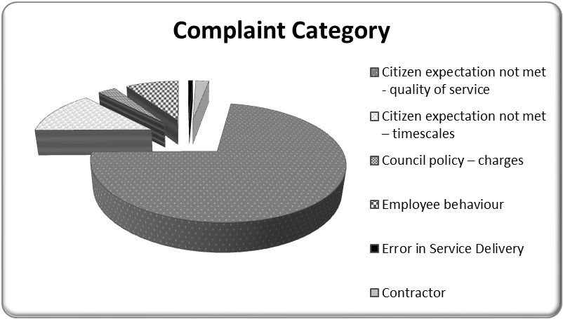

The majority of complaints received by the Regeneration strategic area relate to Building Services. This service area carries out over 50,000 repairs each year and it is important our service users are completely satisfied with the result. We will continue to learn from our complaints information and adapt our processes and procedures if necessary to ensure our service delivery meets the needs of our residents and service users..

In 2017/18 we will implement customer improvement actions (see Appendix 2) to ensure our communication is robust and complaints/enquiries are dealt with in a speedy fashion.

Self-Evaluation Programme
The Council has agreed a three year self-evaluation programme using a checklist approach implemented through an online survey. Over the three year programme, all Council services that are not subject to an external evaluation will undertake self-evaluation, with 11 scheduled in the first year.

Within the Regeneration service area, a self-evaluation was completed with Regeneration and Business Support in January 2017. In 2018, Estates and Compliance will carry out a self-evaluation exercise. All Housing related services are externally evaluated by the Housing Regulator.

.

Strategic Assessment

The regeneration management team completed a detailed strategic assessment and performance review to determine the major influences on service delivery and strategic priorities going forward into 2017/18. As a result of this assessment the following factors were recognised as having a significant influence on the work of service in 2017/18:

Queens Quay
To stimulate the regeneration of the Queens Quay riverside site in Clydebank a land based contract was established between Clydeside Regeneration (CRL) and WDC. This investment was to carry out core infrastructure works to enable land sales to proceed. The mechanism would not only encourage and permit early stage development and fulfill the primary objective of securing much needed economic regeneration but allow both WDC and CRL to share in the sales proceeds.

A Development Agreement was concluded in July 2015 between the Council and CRL. Under terms of the agreement the council will invest up to £15.62M in core infrastructure and associated public realm in return for a share of future land sale receipts arising from the disposal of plots for development.

The original works programme anticipated that works would commence on site during the latter part of 2015 and be complete during 2017/18. However, work commenced on the site in the summer of 2016 but is still expected to be completed for the deadline set of March 18.

Priority for early 2017 will be to work with the private developers and ensure all works are tendered and the delivery of key elements/packages of work commence in 2017/18, including the spine road through the site, basin and quay walls works, together with waterfront public realm and addressing levels and the development of housing plot.

A key project for 2017/18 linked to the Queens Quay development is the opportunity presented through the water source district heating project. With Council support and successful £6m match funding from the Scottish Government Low Carbon Infrastructure Transition Programme (LCITP) the overall Queens Quay development and neighboring facilities will be heated through extracting heat from the water of the River Clyde at the basin adjacent to the Titan Crane. A new Energy centre and significant district heating pipework would be installed and operational by September 2018 to provide a unique and low carbon heat source of scale in Scotland.

Capital Investment
The Council’s revised 10 year Capital Programme was agreed on 24th February 2016. This will enable major investment in upgrading buildings, infrastructure and regeneration across communities. Regeneration has the responsibility to deliver on a number of projects to the value of £200m. Monitoring arrangements for each of these projects will be contained within individual operational plans, with the Strategic Lead overseeing the overall project and budget.

Housing Capital Investment Programme
A refreshed HRA Capital Programme for period 2017/22, total £137M, was approved at Council on 22 February 2017. The main drivers for the programme to allow the Council to meet the requirements of the Scottish Housing Quality Standards (SHQS), the Energy Efficiency Standard for Social Housing (EESSH) and meet its landlord obligations and health and safety responsibilities and deliver the Council’s new build programme.

The HRA Capital Programme is refreshed annually incorporating a new year to maintain a five year programme, this is usually presented to Council in February for approval at the main budget setting Council meeting.

Over 2017/18 the section will continue to deliver on the projects assigned to them and progress will be monitored by the Strategic Lead.

Regeneration Fund
At the Council meeting on 28 October 2015, Council agreed that as part of the review of the ten year capital programme, at least £12.4M should transfer into a Regeneration Capital Fund. The key operating principles of the fund are:

- support the delivery of the Council’s Regeneration and Economic Strategy and the Schools’ Estates Plan;
- accelerate development and regeneration throughout the area;
- ensure the delivery of key projects developed through the Scottish Government Charrette process;
- attract external funding for key projects and where appropriate seek opportunities which will provide a financial return to the council for their Investment;
- and ensure that high quality design is a feature of any investment.

In September 2016 committee approved notional allocation of the Regeneration Fund to deliver key projects primarily from the Charrettes in Clydebank, Bowling, Dumbarton and Balloch.

- Clydebank - The A814 Project involves improving the access for pedestrians to cross the main road in Clydebank at key crossings outside the Clydebank Town Hall and the Queens’ Quay development.

- Bowling – contribute to canal side development at Bowling Basin.

- Dumbarton – From the Dumbarton Rock and Castle Charrette, a project to establish a walk/cycleway from the Town Centre to the Castle

- Balloch - Following the recent Balloch Charrette, the subsequent action plan identified the introduction of two public squares to be established next to the train station and within the village itself.

During 2017/18 the aim of the strategic area is to prepare detailed Proposals/Business Cases for final approval of the projects and their actual funding requirements.

Asset Management
The Council recognises that assets are a key resource that requires to be effectively managed. Effective management of assets is critical to ensuring that assets are utilised in the most effective and efficient manner to enable the delivery of sustainable services to communities. Regeneration is responsible for the strategic management of the Council’s assets, including operational and non-operational properties and is responsible for the delivery of the Corporate Asset Management Plan. The division contributes to the implementation of the Corporate Asset Management Plan through the delivery of key programmes and projects:-

- Building Upgrades
- Deliver savings through effective management of the Council’s Asset Management Strategy
- Management of the CRA
- Reduce energy consumption
- Office rationalisation
- Alternative energy use
- Management of Housing and Public Buildings
- Management of the Commercial Estate

Exxon/ City Deal
The City Deal concept is an agreement between UK and Scottish Governments and at local area on how best to ensure that area's growth and prosperity. This model is promoted by the UK Government as part of its devolution agenda and aims to empower local areas to drive economic growth by putting greater resources and financial freedom through local government.

The Clyde Valley City Deal Involves eight Local Authorities including the City and seven surrounding Authorities. The aim of a Clyde Valley wide Infrastructure Investment Fund is to ensure that all participating Councils will benefit from the fund and that approved projects will be based in or give access to employment for each Council. The key principle of the model is that the local authorities in a city region work together to develop and fund an Infrastructure Investment Programme.

The Clyde Valley infrastructure projects equating to £1.13bn of investment for 20 projects over a ten year period are progressing and have reached various stages from Strategic to Outline Business case.

The Exxon City Deal project for WDC has planned expenditure of £27.897m over the next seven years. The Outline Business Case was approved at Council on 22 February 2017and subsequently at the City Deal Cabinet on 11 April 2017. The priority for 2017/18 will be the conclusion of the agreement on the site transfer from ExxonMobil to the Council and progressing a number of associated pieces of work towards the Final business case (due in October 2019).

Quality
The section has a number of quality standards which have to be adhered to:-

SHQS
The Scottish Housing Quality Standard (SHQS) was introduced in February 2004 and is the Scottish Government’s principal measure of housing quality in Scotland. The deadline for compliance was Apr 2015. The SHQS is a set of five broad housing criteria which must all be met if the property is to pass SHQS.

- Must meet the Tolerable Standard (i.e. the basic legal minimum standard)
- Must be Free from Serious Disrepair
- Must be Energy Efficient
- Must have Modern Facilities and Services
- Must be Healthy, Safe and Secure

West Dunbartonshire Council has met these standards and will now be monitored through the Scottish Social Housing Charter.

EESSH
The Energy Efficiency Standard for Social Housing (EESSH) aims to improve the energy efficiency of social housing in Scotland. It will help to reduce energy consumption, fuel poverty and the emission of greenhouse gases. It will contribute to the Scottish Government’s target of reducing carbon emissions by 42 per cent by 2020 and 80 per cent by 2050 in line with the requirements set out in the Climate Change (Scotland) Act 2009.

Community Asset Transfer
The Community Empowerment Act (Part 5) introduces a right for community bodies to make requests to all local authorities, Scottish Ministers and a wide-ranging list of public bodies, for any land or buildings they feel they could make better use of. Community bodies can request ownership, lease or other rights, as they wish. The Act requires those public authorities to transparently assess requests against a specified list of criteria, and to agree the request unless there are reasonable grounds for refusal. Thus far Regeneration has received applications in relation to the following assets:

- Wylie Park, Renton
- Braehead Community Garden, Bonhill
- Balloch Pier

Fit for Purpose Structures
The challenge to all services is to ensure their structures are right and can delivery best value and demonstrates continuous improvement. In 2017/18 this may involve:-

- Re-designing and re-engineering services
- Increasing income generation
- Investigating alternative service methods – e.g. Shared Service / Trust
- efficient commissioning and procurement
- financial modelling options – e.g. priority based budget

People Management
Regeneration’s main resource is our dedicated workforce. To develop a culture of Best Value and continuous improvement within the department it is important to invest time and resources in staff.

Throughout 2017/18 we will:

- Carry out Be the Best Conversations with staff;
- Rigorously apply the Council’s Attendance Management Policy
- Monitor our complaint handling process to ensure we are meeting the agreed timescales

Equalities
To reduce inequalities, the Council has set out nine equality outcomes for 2017/21 in line with its statutory duty, each led by a relevant strategic lead area. By focusing on outcomes, the Council aims to bring practical improvements to the life chances of those who experience discrimination and disadvantage.

While Regeneration is not leading on any specific equality outcome, we will review and identify actions to address the four council wide equality outcomes for 2017/21, relating to community participation, employment diversity, disability pay gap, and occupational segregation.

Together with the outcome of the performance review for 2016/17, the issues raised through the strategic assessment will inform the work of the strategic area over the period of this plan, influencing the service priorities and objectives and planned actions for 2017/18 and beyond.

Resources
As a Council we are committed to supporting every employee to ‘Be the Best’ through providing personal development opportunities and ensuring that our employees feel valued and recognised for their contribution in delivering the Council’s vision and strategic objectives. This commitment is achieved through ensuring all employees have a PDP in place and supporting professional and personal development in their current role and for any future career plan.

From 2017 onwards employee development will be delivered through Be the Best conversions. This process will ensure all employees receive a valuable meaningful discussion around how they can Be the Best in their role and receive support and development to allow them to accomplish their potential.

Our development priorities include training; leadership and manager development; customer service; change management; technical skills and specialist skills that support and maintain professional expertise. Our commitment to learning and development is recognised through the achievement of Gold Standard from Investors in People (IiP).

Workforce Planning
Workforce planning is integrated within the strategic planning process, highlighting the key workforce related activities for the year and reflecting the longer term strategic aims of the services. Each Strategic Lead is responsible for the annual review of requirements for their respective service areas to ensure that any key actions are identified at an early stage.

We gather the views of our employees through our regular employee survey, the most recent survey results relate to the survey carried out at the end of 2015. From this an organisational improvement plan has been put in place. These improvement activities focus on 5 key areas and will be delivered through activities in each service across the organisation.

The number of full time equivalent staff in each section is outlined below:-

 | Total
Capital Investment | 10.00
Economic Development | 12.63
Estates & Asset Management | 47.28
Housing Asset & Investment | 12.60
Maintenance & Repairs | 337.79
Regeneration Total | 420.30

Employee Wellbeing Group
The newly established Employee Wellbeing Group will develop and oversee the implementation of a Council strategy (and resulting implementation plans) which will seek to maximise employee wellbeing, recognising the benefits to the organisation and its employees of such an approach. Linked to this, work will be undertaken with managers and trades union partners to embed a ‘safety culture’, fostering increased ownership and accountability across the organisation as a whole.

Finance
The 2017/18 revenue budget for regeneration as a strategic area is net income of £1.563m. In additional to this the service has the capital budget listed below. We will make the best use of the resources available to deliver on key priority areas and secure external funding where we can.

The resources to deliver on this 2017/18 action plan for Regeneration are:-

Budget
Section | Expenditure | Income | Capital Budget
Economic Development | 1.307m | 0.825m | 18.342m
Corporate Asset Management | 2.612m | 4.851m | 9.470m
Capital Investment | 0.545m | 0.545m | 37.003m
Housing Maintenance Trading Account | 20.248m | 21.766m | n/a
Central Revenue Account (Central Repairs and Maintenance) | 2.417m | 1.120m | n/a
Housing Asset & Investment | n/a | n/a | 28,037

Risks

The Council has identified risks at both a strategic and service level. Strategic risks represent the potential for the Council to take advantage of opportunities or fail to meet stated strategic objectives and those that require strategic leadership. Service risks relate to service delivery and represent the potential for impact on individual services, or the experience of those who work within the services, i.e. employees, partners, contractors and volunteers, service users or clients in receipt of the services provided.

In planning for 2017/18, the Regeneration management team considered the Council’s strategic risks and identified risks specific to the service (below).

Actions to mitigate these risks are set out in our action plan at Appendix 2 or in our operational plans, with the aim of improving or maintaining the current position (i.e. the current risk score).

Regeneration services delivery a significant number of key projects on behalf of the Council. Each of these projects are assessed for risk with actions developed to mitigate risk. These risks are managed through each service’s operational plan.

Risk Title | Risk Description | Current Risk Score | Target Risk Score
Council estate and facilities are not fit for purpose | The Council's assets and facilities are not fully fit for purpose with consequent adverse impact on our ability to deliver efficient and effective services. Included in this assessment is Council’s property portfolio, housing stock, roads and lighting, fleet and open space | 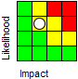

Appendix 1 – Regeneration Structure Chart
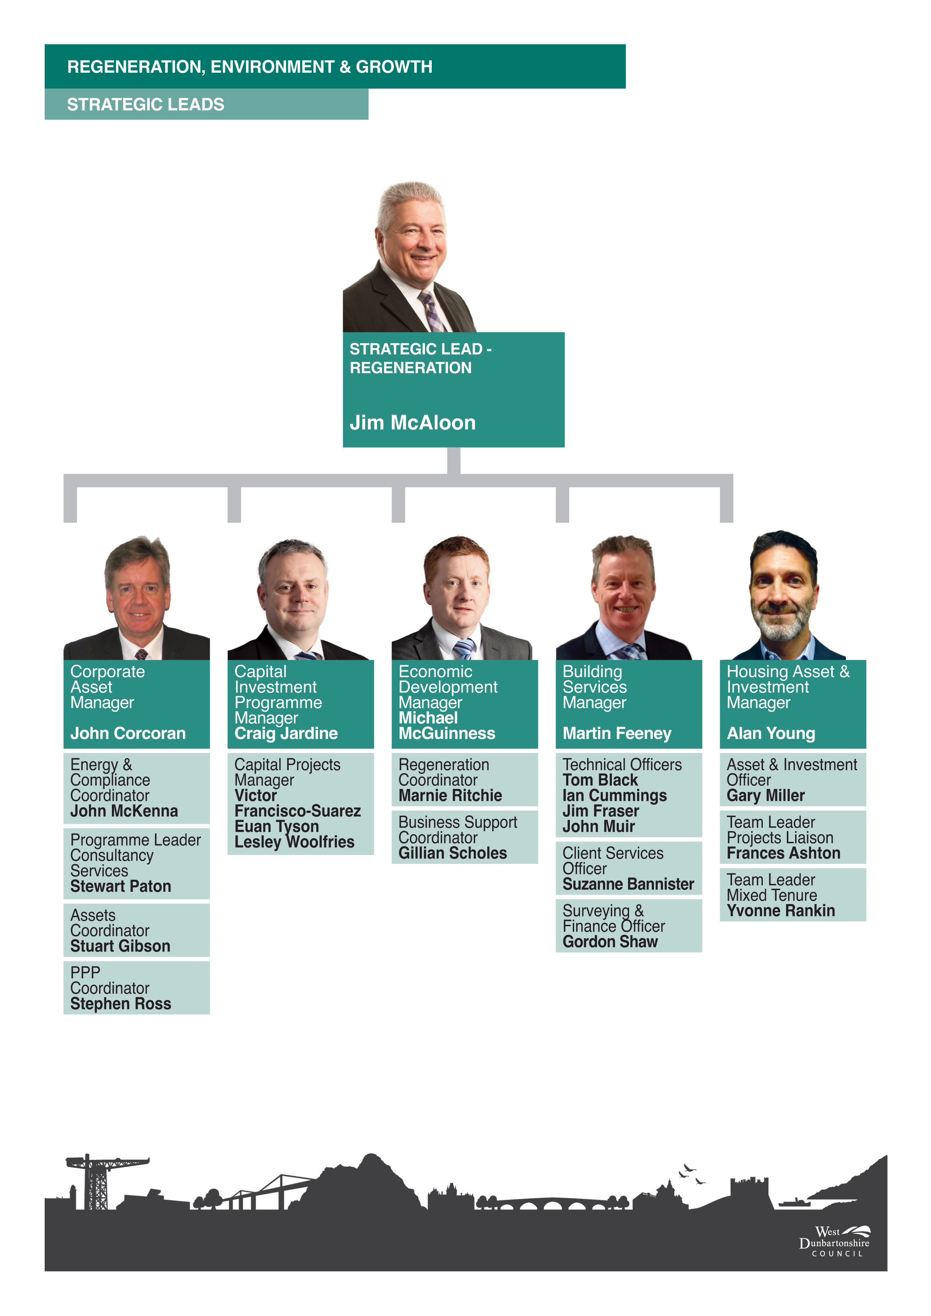

Appendix 2 - Action Plan 2017-18

Priority | Outcome | Action | Assigned to
Social Mission | Improved economic growth and employability | Continue the development of Queens Quay and the implementation of a district heating network within the site. | Michael McGuinness
Social Mission | Improved economic growth and employability | Deliver key projects from the Regeneration Fund | Michael McGuinness
Social Mission | Improved economic growth and employability | Conclude the agreement on the site transfer from ExxonMobil to the Council and progressing a number of associated pieces of work towards the Final business case | Jim McAloon
Social Mission | Improved economic growth and employability | Ensure the Council’s Housing stock progresses towards the achievement of the energy efficiency standard for social housing by 2020 | Alan Young
Social Mission | Improved economic growth and employability | Deliver the allocated General Services investment programme project scheduled for delivery in 2011/18 | Craig Jardine
Social Mission | Improved local housing and environmentally sustainable infrastructure | Deliver the HRA Capital Investment programme for 2017/18 | Alan Young
Social Mission |  | Deliver savings through effective management of the Council’s Asset Management Strategy | John Corcoran
Social Mission |  | Commercialise the Housing DLO by identifying external clients and contracting for additional works | Martin Feeney
Social Mission |  | Develop and implement Community Asset Transfer Policy | John Corcoran
Social Mission |  | Ensure the Council’s Housing stock progresses towards the achievement of the energy efficiency standard for social housing by 2020 | Alan Young
Social Mission |  | Continue to grow Building Services by increasing external income to support front line services. | Martin Feeney
Legitimacy and support | Positive dialogue with local citizens and communities | Ensure a consistent and robust approach to customer service improvement across the strategic area | Jim McAloon
Organisational capabilities | Strong financial governance and sustainable budget management | Maximise procurement benefit | Jim McAloon
Organisational capabilities | Committed and dynamic workforce | Develop, implement and evaluate a local action plan, in line with the Council’s employee wellbeing strategy | Jim McAloon
Organisational capabilities | Committed and dynamic workforce | Support implementation of Be the Best conversations through role modelling best practice, clear communications, and providing regular encouragement for all service areas to ensure Be the Best conversations are taking place for all employees. | Jim McAloon

Appendix 3: Performance Indicators 2017-18

The following performance indicators will be integrated in the Action Plan (Appendix 2) and monitored, managed and reported in accordance with the Performance Management Framework:
Strategic Plan PIs:

H/CAM/10 | Tonnage of carbon dioxide emissions from Council operations and assets
H/ED/020 | Number of businesses given advice and assistance to start up through Business Gateway
H/ED/034 | Percentage of all people aged 16-64 years in employment
SCORPAM02 | Proportion of internal floor area of operational buildings in satisfactory condition %
SHSN03 | % of council dwellings that meet the Scottish Housing Quality Standard

Local Government Benchmarking Framework PIs:
SCORPAM01 | Proportion of operational buildings that are suitable for their current use %
SCORPAM02 | Proportion of internal floor area of operational buildings in satisfactory condition %
SHSN03 | % of council dwellings that meet the Scottish Housing Quality Standard
SHSN04b | Average time taken to complete non-emergency repairs
SHSN05 | Percentage of council houses that are energy efficient %

Local PIs:

SCM4b | CM4c: Percentage of council buildings in which all public areas are suitable for and accessible to disabled people
H/CAM/10 | Tonnage of carbon dioxide emissions from Council operations and assets
H/SSHC/CI/11 | Average length of time taken to complete emergency repairs
H/SSHC/CI/13 | Percentage of reactive repairs carried out completed right first time
H/SSHC/CI/14 | Percentage of repairs appointments kept

Appendix 4: Workforce Plan 2017-18

2017/18 Regeneration and Business Development Workforce Plan

Introduction

The purpose of this Workforce Plan is to highlight and plan for the management of key workforce issues which are necessary to fully support the delivery of the Strategic Lead area Delivery Plan. These workforce issues cover the full period of the Delivery Plan and have significant implications in terms of organisational change, resource planning, resource profiling, skill mix, learning and development and restructuring.

The plan also provides details of the current workforce profile of the Strategic Lead area, allowing for observations and assumptions to be drawn based upon workforce demographics and the impact this has in relation to resources and service delivery. Sickness absence information has also been included as reduction in this area is a key service priority for the council.

The plan is broken down as follows:

- Summary of the Key Service Priorities/Issues and Resource Implications;
- Longer term Key Service Priorities/ Issues and Resource implications; and
- Establishment and resource Information.

1. Summary of the Key Service Priorities/Issues and Resource Implications
The table below provides details of priorities or issues which will happen and conclude during the current financial year and their implications.
Priority/ Issues | Resource or Skill implication | Action required | Cost/Saving | Lead Officer
School Estate to be focused on Primary and Early Years. | No impact on project team. | Contracts to continue on a fixed term basis. | n/a. | C Jardine.
Deliver the allocated General Services Capital investment programme project scheduled for 2017/18 | Approved staffing levels need to be maintained. | Staff re-aligned to support Exxon and other strategic capital project. | Costs charged to Capital Programme | C Jardine
Delivery of the HRA Capital Investment programme for 2017/18. | The projects within the Capital Investment programme awarded to Maintenance and Repairs will provide staff with opportunities to enhance and develop skills in new areas of work.  Awarding projects to the DLO will enable this service to provide job opportunities to apprentices on a fixed term basis. | Review current and future staffing requirements.  Job opportunities advertised 2016/17. | Costs charged to HRA Capital Programme. | Alan Young
Ensure housing stock progresses towards the achievement of the (EESH) standards by 2020 | 40 staff recruited on fixed term contracts to meet SHQS standards being retained for a further fixed term to meet EESH standards. | Review current and future staffing requirements.  Consultation with employees and trade unions on changes to trades requirements for new programme of work.  Additional 60 craft employees currently being recruited on a fixed term basis.  Apprentices due to complete their apprenticeship this year will be offered a fixed term contract due to additional work being progressed by the DLO. | Cost charged to HRA Capital Programme | Martin Feeney
Implementation of Management Savings and ongoing restructuring across services. | Potential reduction in staffing numbers.  Retraining/redeployment of staff. | Staff and trade union briefings.  Consultation with employees. |  | All Managers.
Improvement in attendance. | Reduce staff absence across regeneration and associated costs.  Council target 2017/18  7 days lost per employee | Target specific problem areas.  Develop specific actions to address areas of concern. | Savings dependant on reduction in number of days lost. | All Managers.
Implement Be the Best Conversations throughout service(s). | All employees. | Target of 100% by 2018. |  | All Managers.

- Longer term Key Service Priorities/ Issues and Resource implications

This section details priorities or issues, which will start in the next financial year but will conclude beyond this period or have been agreed in this financial year but will commence at a later date.
Period that priority will impact over | Priority/ Issues | Potential resource or skill implication | Potential actions required | Cost/  Savings | Lead Officer
2017-2018 | Move to new Dumbarton Office. | Review of structure and new ways of working. | Build Programme to be completed by Dec 2017. | TBC | C Jardine
Ongoing | Changes to the School estate. | Changes to school estate will have an impact on staff – change management, staffing and other training requirements | Amalgamating / closing schools | Dependant on the options taken | C Jardine
2017-2018 | Develop a range of savings options to achieve budget savings targets. | Review current and future staffing requirements.  Potential redeployment voluntary redundancy /early retirement. | Scope and review structure to identify potential savings. | 4% savings to be generated. | All Managers.

- Establishment and Resource Information
The data listed below relates to the profile of the Strategic Lead area workforce as at 1st April 2017 and examines changes in that profile over time. Comparison is not provided in instances where new workforce profile information is being reported for the first time.

- Head Count

 | Apprentice | Casual | Fixed-Term | Permanent | Total
Capital Investment | 0 | 0 | 5 | 5 | 10
Economic Development | 0 | 0 | 2 | 12 | 14
Estates & Asset Management | 0 | 0 | 6 | 43 | 49
Housing Asset & Invest | 0 | 0 | 0 | 13 | 13
Building Services | 25 | 0 | 113 | 202 | 340
Regeneration Total | 25 | 0 | 126 | 275 | 426

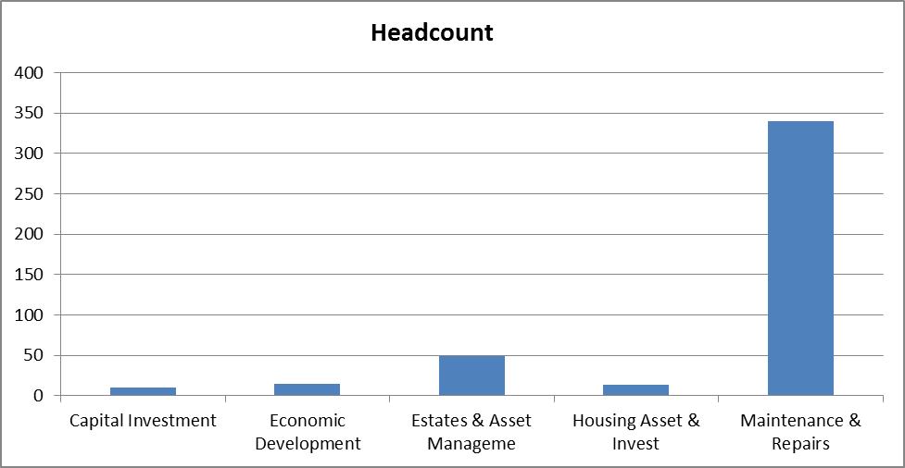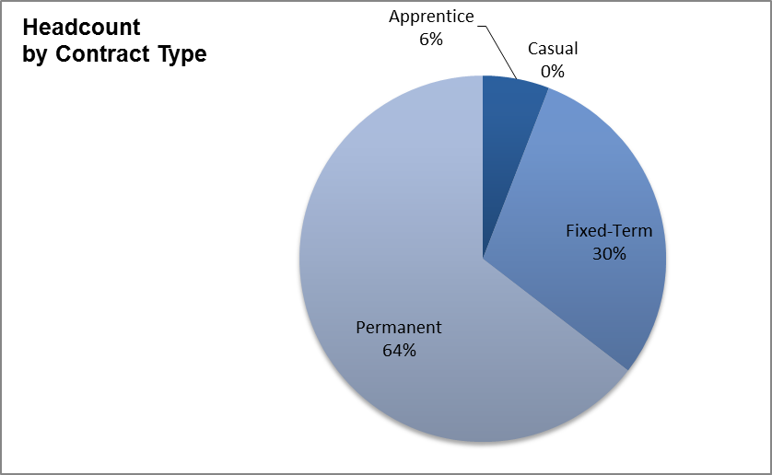

Regeneration and Business Development employ 426 staff (420.30FTE). The majority of these staff are employed within Building Services who provide a responsive repair service for the Council’s housing, public and commercial buildings and external organisations and are responsible for the delivery of HRA Capital Investment programme. This capital investment programme will provide opportunities for staff to enhance and develop new skills in new areas of work and provide employment opportunities for apprentices and skilled tradespersons during 2017/18. 30% of staff employed within regeneration are employed on a fixed term basis as a significant amount of work is associated with projects aligned to the delivery of the Council’s 10 year Capital Programme, General Services Investment Programme, the HRA Capital Investment Programme and Housing Stock EESH standards (2020).

- Full-time Equivalent

 | Apprentice | Fixed-Term | Permanent | Total
Capital Investment | 0.00 | 5.00 | 5.00 | 10.00
Economic Development | 0.00 | 1.80 | 10.83 | 12.63
Estates & Asset Management | 0.00 | 5.62 | 41.66 | 47.28
Housing Asset & Investment | 0.00 | 0.00 | 12.60 | 12.60
Maintenance & Repairs | 25.00 | 113.00 | 199.79 | 337.79
Regeneration Total | 25.00 | 125.42 | 269.88 | 420.30

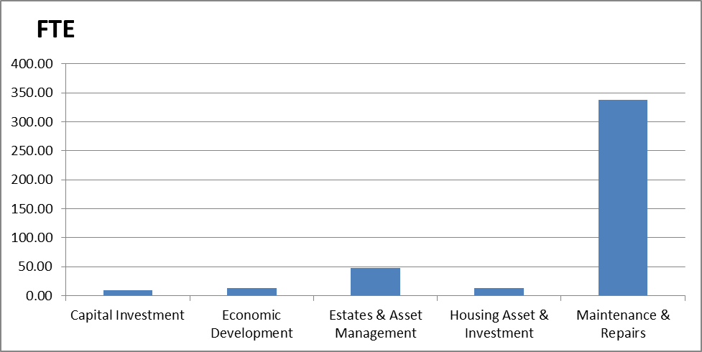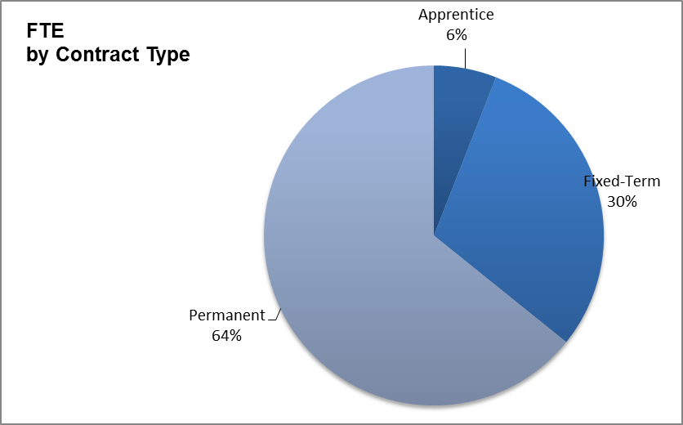
- Fixed-Term Contracts

 | FTCs Ending in Next 6 Months | FTCs Longer than 2 Years
Capital Investment | 0 | 4
Economic Development | 2 | 0
Estates & Asset Management | 5 | 1
Housing Asset & Investment | 0 | 0
Maintenance & Repairs | 85 | 39
Regeneration Total | 92 | 44

There are 92 employees on a fixed term contract with an ending date within the next 6 months. There is also a significant number of employees who have been on a fixed term contract for more than 2 years but none for more than 4 years.
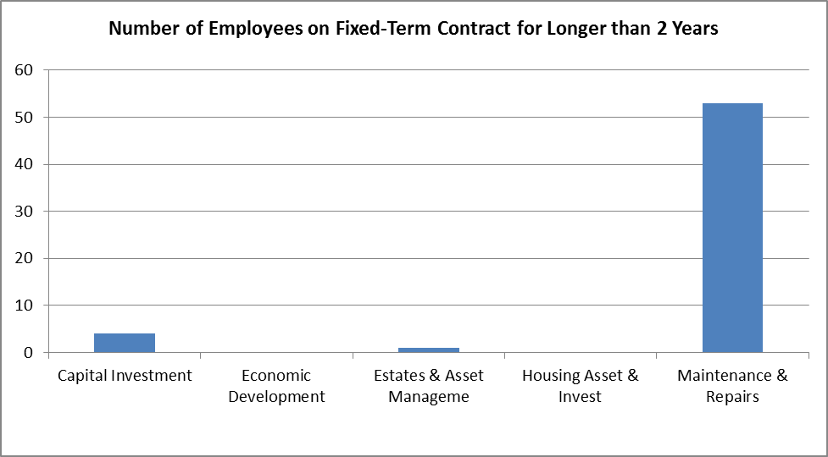
- Full-time/Part-time Split

 | Full-Time | Part-Time
Capital Investment | 10 | 0
Economic Development | 10 | 4
Estates & Asset Management | 43 | 6
Housing Asset & Investment | 12 | 1
Building Services | 330 | 10
Regeneration Total | 405 | 21

As shown, 95% of the workforce employed in regeneration is engaged on a full-time basis and 5% as part-time.

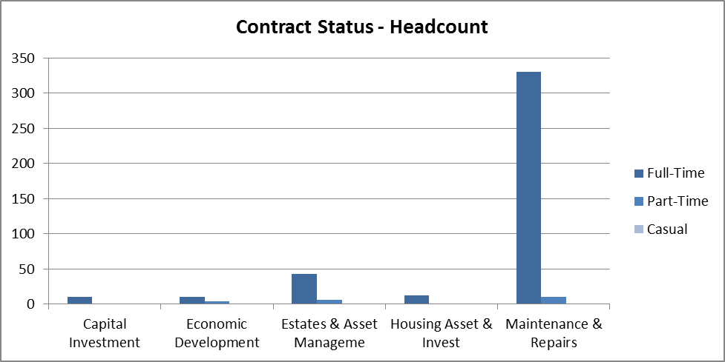
- Grade Profile

Number of staff in each grade
 | Grade 1 | Grade 2 | Grade 3 | Grade 4 | Grade 5 | Grade 6 | Grade 7 | Grade 8 | Grade 9 | Grade 10 | Grade 11 | Grade 12 | Apprentice | Total
Capital Investment | 0 | 0 | 0 | 0 | 0 | 1 | 0 | 5 | 0 | 3 | 0 | 1 | 0 | 10
Economic Development | 0 | 0 | 0 | 0 | 4 | 0 | 0 | 7 | 1 | 1 | 0 | 1 | 0 | 14
Estates & Asset Management | 0 | 0 | 4 | 0 | 1 | 7 | 10 | 22 | 2 | 2 | 0 | 1 | 0 | 49
Housing Asset & Investment | 0 | 0 | 0 | 0 | 0 | 9 | 2 | 1 | 0 | 0 | 1 | 0 | 0 | 13
Building Services | 0 | 0 | 6 | 28 | 242 | 32 | 0 | 6 | 0 | 0 | 1 | 0 | 25 | 340
Regeneration Total | 0 | 0 | 10 | 28 | 247 | 49 | 12 | 41 | 3 | 6 | 2 | 3 | 25 | 426
80% of staff employed within regeneration are employed within building services, the highest percentage (57%) of which are Grade 5 tradespersons, 9.4% are Grade 6 craft supervisors and 7% are apprentices. Those employed in Grade 7 – Grade 12 within regeneration have a professionalism and/or line management responsibility.

Percentage of staff under each grade
 | Grade 3 | Grade 4 | Grade 5 | Grade 6 | Grade 7 | Grade 8 | Grade 9 | Grade 10 | Grade 11 | Grade 12 | Mod Appren
Capital Investment | 0.0% | 0.0% | 0.0% | 10.0% | 0.0% | 50.0% | 0.0% | 30.0% | 0.0% | 10.0% | 0.0%
Economic Development | 0.0% | 0.0% | 28.6% | 0.0% | 0.0% | 50.0% | 7.1% | 7.1% | 0.0% | 7.1% | 0.0%
Estates & Asset Management | 8.2% | 0.0% | 2.0% | 14.3% | 20.4% | 44.9% | 4.1% | 4.1% | 0.0% | 2.0% | 0.0%
Housing Asset & Investment | 0.0% | 0.0% | 0.0% | 69.2% | 15.4% | 7.7% | 0.0% | 0.0% | 7.7% | 0.0% | 0.0%
Maintenance & Repairs | 1.8% | 8.2% | 71.2% | 9.4% | 0.0% | 1.8% | 0.0% | 0.0% | 0.3% | 0.0% | 7.4%
Regeneration Total | 2.3% | 6.6% | 58.0% | 11.5% | 2.8% | 9.6% | 0.7% | 1.4% | 0.5% | 0.7% | 5.9%

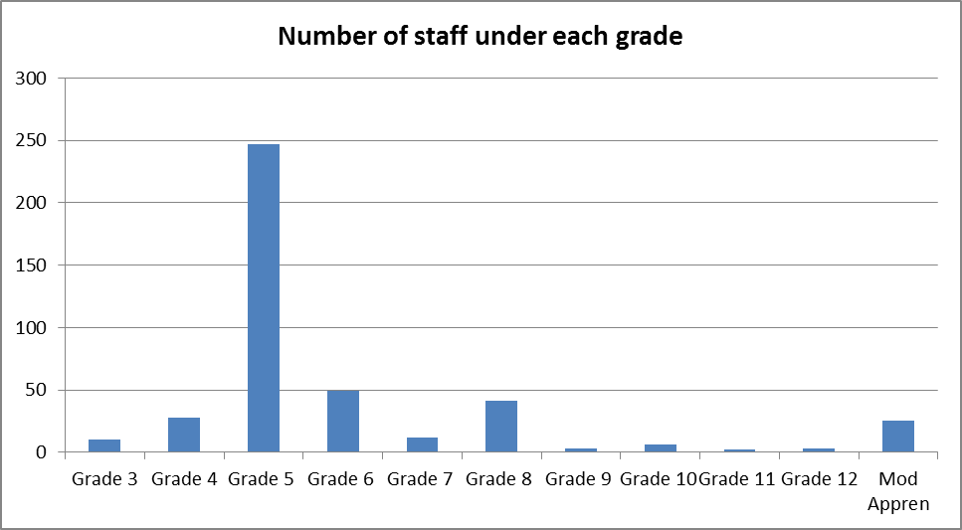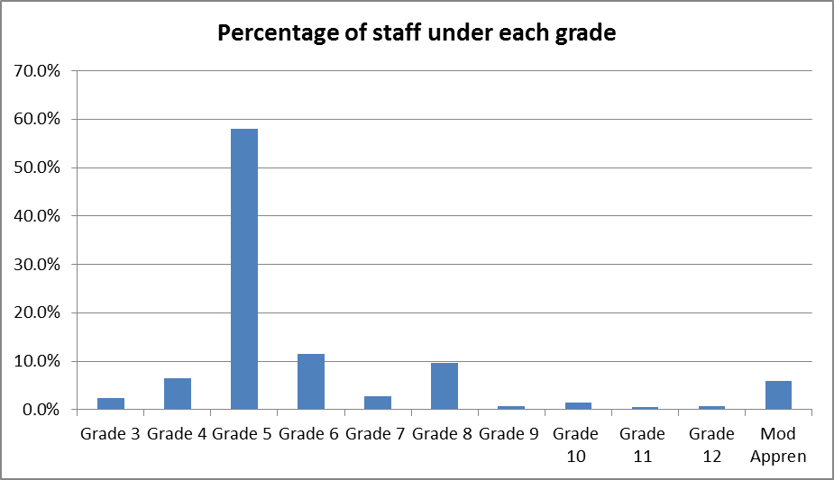
- Gender Profile
 | Female |  | Male
 | Headcount | Percentage | Headcount | Percentage
Capital Investment | 5 | 50.0% | 5 | 50.0%
Economic Development | 11 | 78.6% | 3 | 21.4%
Estates & Asset Management | 15 | 30.6% | 34 | 69.4%
Housing Asset & Investment | 7 | 53.8% | 6 | 46.2%
Maintenance & Repairs | 15 | 4.4% | 325 | 95.6%
Regeneration Total | 53 | 12.4% | 373 | 87.6%

12% of staff employed within Regeneration is female and 88% male. This imbalance is mainly due to the significant number of male staff employed within Building Services.
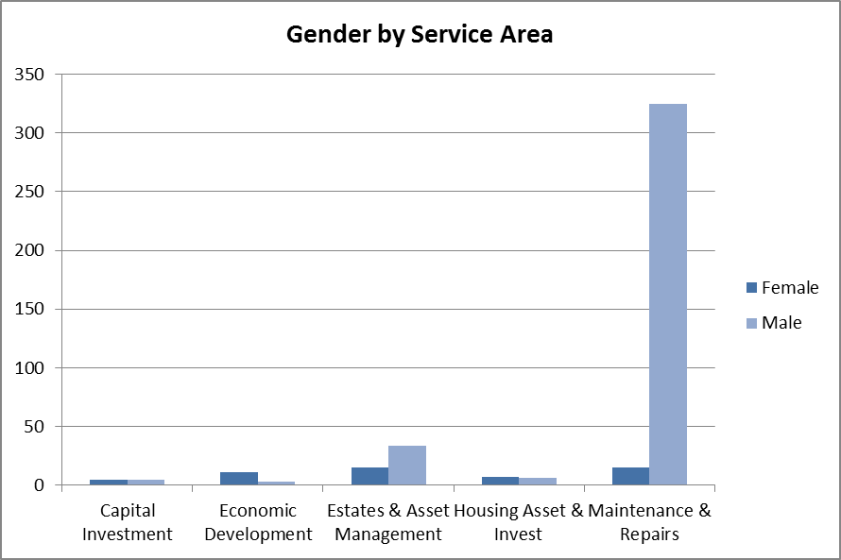

- Age Profile

Age Profile – Headcount

 | 16-19 | 20-24 | 25-29 | 30-34 | 35-39 | 40-44 | 45-49 | 50-54 | 55-59 | 60-64 | 65+
Capital Investment | 0 | 0 | 0 | 0 | 1 | 2 | 4 | 2 | 1 | 0 | 0
Economic Development | 0 | 1 | 1 | 1 | 2 | 3 | 4 | 1 | 1 | 0 | 0
Estates & Asset Management | 0 | 1 | 1 | 3 | 7 | 3 | 9 | 6 | 9 | 9 | 1
Housing Asset & Investment | 0 | 0 | 0 | 0 | 1 | 2 | 3 | 3 | 2 | 1 | 1
Maintenance & Repairs | 6 | 30 | 36 | 38 | 24 | 30 | 40 | 67 | 39 | 27 | 3
Regeneration Total | 6 | 32 | 38 | 42 | 35 | 40 | 60 | 79 | 52 | 37 | 5

The age profile within Regeneration services displays a number of workforce characteristics which are important in relation to our workforce planning processes. 1.2% of the workforce in Regeneration is over 65, 8.7% are aged between 60-64, 12.2% between 55-59 and 18.5% between 50 and 54 therefore overall 40.6% are over 50 23.5% are between 40-49, 18.1% between 30-39 and 17.8% are under 30.
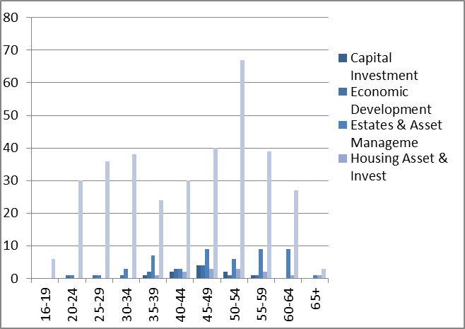

- Length of service with WDC
 | Less than 1 year |  | 1 to 9 years |  | 10 or more years
 | Headcount | Percentage | Headcount | Percentage | Headcount | Percentage
Capital Investment | 0 | 0.0% | 7 | 70.0% | 3 | 30.0%
Economic Development | 0 | 0.0% | 9 | 64.3% | 5 | 35.7%
Estates & Asset Management | 3 | 6.1% | 28 | 57.1% | 18 | 36.7%
Housing Asset & Investment | 0 | 0.0% | 1 | 7.7% | 12 | 92.3%
Building Services | 46 | 13.5% | 117 | 34.4% | 177 | 52.1%
Regeneration Total | 49 | 11.5% | 162 | 38.0% | 215 | 50.5%
50.5% of the workforce have been employed with the Council for more than 10 years, 38.0% between 1 and 9 years and 11.5% have been employed for less than a year. This reflects the additional recruitment which has been undertaken during 2016-17 within Building Services to increase resources to progress additional work awarded inhouse to complete the HRA Capital Investment Programme, Capital Investment Programme and Housing (EESH) standards. The chart below shows a trend towards older employees within the Strategic Lead area. A significant majority of employees within Regeneration have been employed for 10 or more years and this is reported predominantly within Housing Asset & Investment where 92.3% of all employees have 10 or more years’ service.
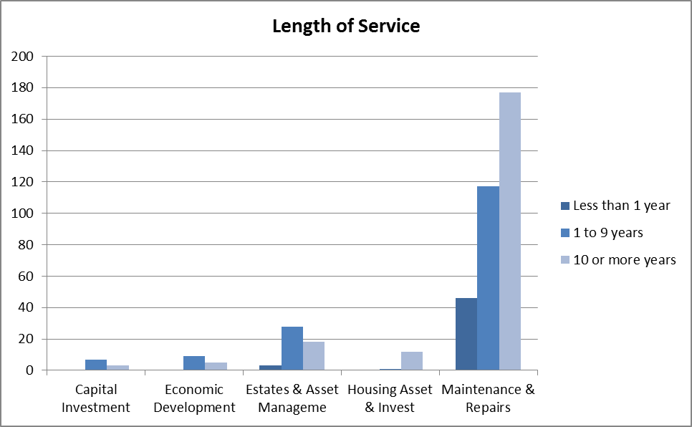

- New Start Employees

 | Apprentice | Fixed-Term | Permanent
Capital Investment | 0 | 0 | 0
Economic Development | 0 | 0 | 0
Estates & Asset Management | 0 | 2 | 1
Housing Asset & Investment | 0 | 0 | 0
Maintenance & Repairs | 5 | 41 | 0
Regeneration Total | 5 | 43 | 1

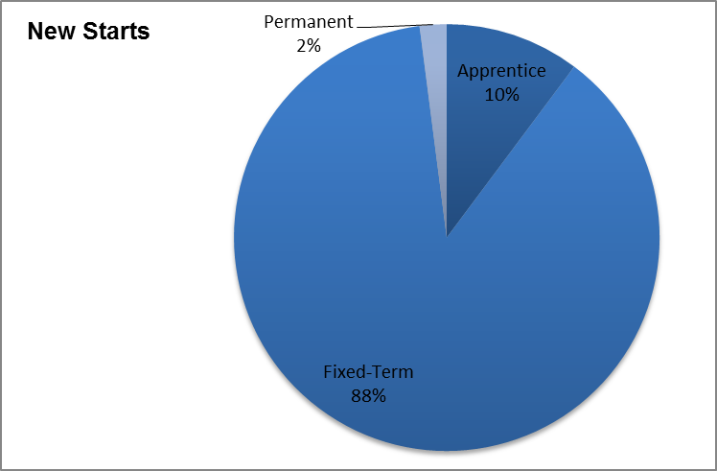

Recruitment within building services has increased significantly this year. The majority of employees recruited are fixed term to progress additional work associated with Housing Capital Projects and Housing EESH standards.

- Turnover

 | Staff at 1 April 2016 | Staff at 1 April 2017 | Average | Leavers | Turnover %
Capital Investment | 11 | 10 | 11 | 0 | 0.00%
Economic Development | 15 | 14 | 15 | 1 | 6.90%
Estates & Asset Management | 55 | 49 | 52 | 9 | 17.31%
Housing Asset & Investment | 23 | 13 | 18 | 1 | 5.56%
Maintenance & Repairs | 341 | 340 | 341 | 21 | 6.17%
Strategy & Improvement* | 2 | 0 | 1 | 0 | 0.00%
Regeneration Total | 447 | 426 | 437 | 32 | 7.32%
*Please note that those employed in Strategy & Improvement moved to a different Strategic Lead area as a result of organisational restructure
during the course of 2016/17.
Turnover is relatively low within the service and comparable with Council overall for 2015/16.

- Leavers

 | Death in Service | Dismissal - End of Cont | Dismissal - Ill Heath | Employee Not Started | Resignation | Retiral - Age | Retiral - Ill Health | Retiral on Option (60+) | Total
Capital Investment | 0 | 0 | 0 | 0 | 0 | 0 | 0 | 0 | 0
Economic Development | 0 | 0 | 0 | 0 | 0 | 1 | 0 | 0 | 1
Estates & Asset Management | 0 | 1 | 0 | 0 | 6 | 1 | 0 | 1 | 9
Housing Asset & Investment | 0 | 0 | 0 | 0 | 0 | 0 | 0 | 1 | 1
Building Services | 1 | 0 | 0 | 1 | 11 | 4 | 3 | 1 | 21
Regeneration Total | 1 | 1 | 0 | 1 | 17 | 6 | 3 | 3 | 32

The leavers statistic 2016-17 with a total of 31 leavers has increased by 61% when compared to 2015-16 when 19 staff left
the service. The predominant reason for leaving is resignation and this was highest within Building Services which increased from
5 in 2015-16 to 11 in 2016-17 and from 3 to 5 within Estates and Asset Management. The number of employees retiring on age
increased from 2 in 2015 -16 to 6 in 2016-17 and there was also an increase in Retirement on Option (60+) from 0 in 2015-16
to 3 in 2016-17.

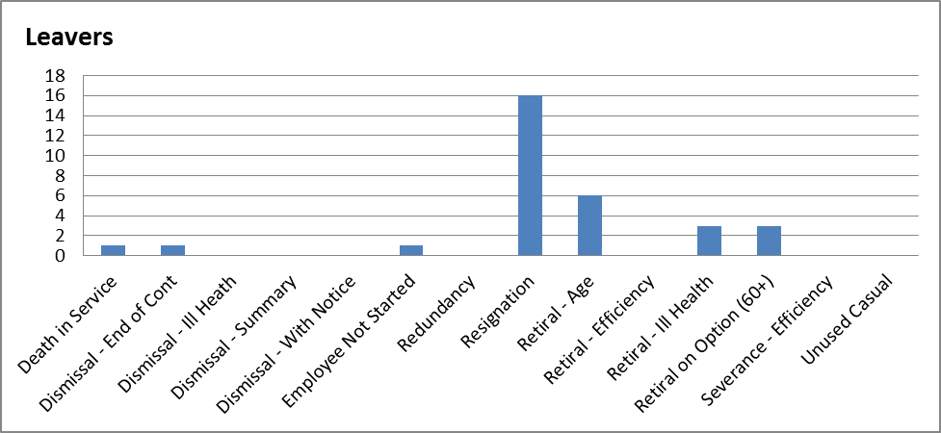

Number of staff who left in their first year of employment with WDC
 | Headcount
Capital Investment | 0
Economic Development | 0
Estates & Asset Management | 0
Housing Asset & Investment | 0
Building Services | 2
Regeneration Total | 2

- Apprentices
 | Level 2 | Level 3 | Total
Capital Investment | 0 | 0 | 0
Economic Development | 0 | 0 | 0
Estates & Asset Management | 0 | 0 | 0
Housing Asset & Invest | 0 | 0 | 0
Maintenance & Repairs | 0 | 25 | 25
Regeneration Total | 0 | 25 | 25

The number of apprentices within regeneration decreased from 32 in 2015-16 to 25 in 2016-17.

- Maternity/Paternity Leave

 | Maternity Leave | Paternity Leave | Total | % of employees
Capital Investment | 0 | 0 | 0 | 0.0%
Economic Development | 0 | 0 | 0 | 0.0%
Estates & Asset Management | 1 | 1 | 2 | 3.8%
Housing Asset & Investment | 0 | 0 | 0 | 0.0%
Building Services | 1 | 4 | 5 | 1.5%
Regeneration Total | 2 | 5 | 7 | 1.6%

There has been no significant change in the number of employees who were off on maternity/paternity leave this year. The numbers are reflective of the demographics of the workforce.

- Sick Absence

 | April | May | June | July | Aug | Sept | Oct | Nov | Dec | Jan | Feb | Mar | Year End
2016/17 | 0.85 | 0.98 | 0.85 | 1.06 | 1.07 | 1.04 | 0.98 | 0.95 | 1.19 | 0.6 | 0.78 | 1.02 | 11.19

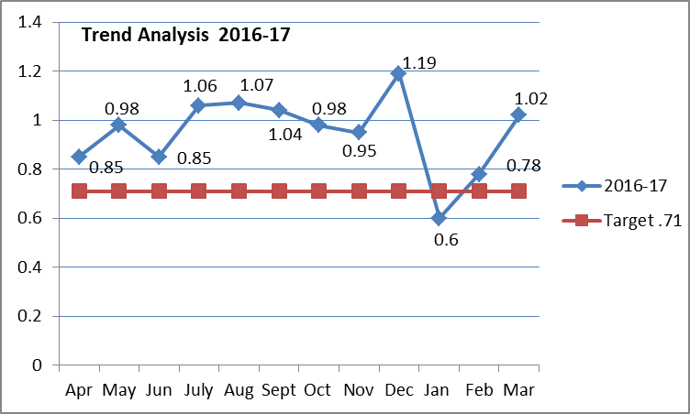

The graph details the monthly trend for the 12 month period (April 2016 – March 2017) Regeneration recorded absences of 11.19 FTE days lost in 2016-17and did not meet target of 8.5 FTE days per employee mainly due to high absence within Building Services where absence increased by 3% year on year during 2016/17 from 11.82 FTE days lost in 2015/16 to 12.18 FTE days lost in 2016/17.

There is no comparator data for 2015-16 due to structural changes where Planning and Building Standards moved Regulatory Services, Strategy & Improvement moved to Policy Planning and Performance and Building Services and Housing Asset & Investment moved to Regeneration.

