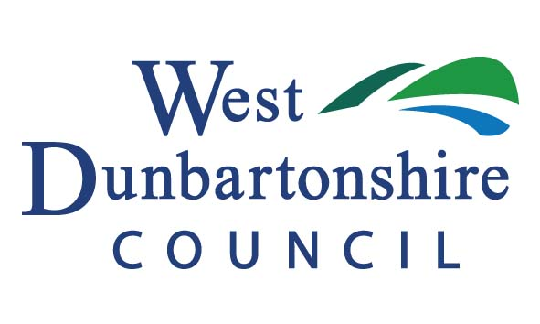
GRANTS TO OLDER PEOPLE & OLDER PEOPLES GROUPS
INDIVIDUAL NOMINATION FORM 2018

Please read the General Information prior to completing this form as the criteria for applying is changing for future years
This form should only be completed for new applications or amendments to previous information provided.
If you have already completed a form in previous years and your details have not changed, you do not need to do anything. The details you provided previously will be used.

Please confirm:
This is a new application form being submitted, I have not applied in previous years
This is a revised application – I would like to update information I have previously provided
Title:

First Name/s:

Surname:

Address:

Post Code:

Telephone Number:

Date of Birth:

If you have moved address within West Dunbartonshire Council in the last year, please provide details of your previous address here:

This section should be used to advise WDC if you wish to nominate your share of funding to either a group that has been nominated in the past or a different group
Please find below a list of groups which have been nominated by individuals in the past, however please note that this list is not exhaustive and other groups in the area can be nominated.
GROUPS IN RECEIPT OF FUNDING FROM WEST DUNBARTONSHIRE COUNCIL IN 2017
Duntocher Old People’s Welfare | St Patrick’s Senior Citizens | Christie Park Veterans Bowling Club
Age Concern Vale of Leven | Vale of Leven Arthritis Club | Dalmonach Tuesday/Friday Club
Age Concern Renton | Good Companions | Kilmaronock Old People’s Welfare
Bowling Senior Citizens W.C. | Wednesday Night Bingo Club | Dumbarton Veterans Bowling Club
Dalvait and Carrochan Older People’s Welfare | Bonhill Senior Citizen’s Association | Levenvale Older People’s Welfare
Levenside Senior Citizen’s | Age Concern Dumbarton | Bonhill & Jamestown Older People’s Association
Alexandria & District Diabetes Group | Alexandria Gardening Club
1. Do you want to nominate your share of funding to a group? YES/ NO
2. If yes, what is the name of the group? Please also provide contact details (we will get in touch with the group for the information we require from them)
Group Name

Name of Person to Contact
Contact Address
Telephone number
Contact email address

3. If no, you are required to receive your allocation of the funding directly into your bank account (to receive funding directly, you must provide details of your bank account. Your account must accept incoming payments)

This section should be used to advise WDC of the bank account details that individual payments should be made to. We will not disclose your details to anyone or use them for any other purpose

4. Please give details of your bank account:
Name of bank:

Address of Bank:

Sort Code
(This must be a six digit number – no letters)
Account Number (This must be an eight digit number – no letters)
Account holders name:

5. Please confirm this is YOUR bank account (even if it’s a joint account): YES/NO

6. If it is not your bank account, please confirm you will receive benefit from this: YES/NO

I confirm that the above information is correct
Signature: …………………………………………………………………………………………..

Date: ………………………………………………………………………………………………….
This short form Privacy Notice is provided for the purposes of the General Data Protection Regulation (GDPR) and is provided for all West Dunbartonshire Council services.
We will use your personal details (known as Personal Data) to provide you with the service(s) which you or someone else (with your consent) have asked us to provide as part of a contract or where we are under obligation to do so (public task or legal obligation). We will also use your personal details for purposes of crime prevention and crime detection and/or when required by law and will share it with other public bodies for that purpose.
For a fuller description of how we handle your data please see our Privacy Notice.
Should you require a paper copy of our Privacy Notice, please contact us.

