Office use only: | Owner Ref:

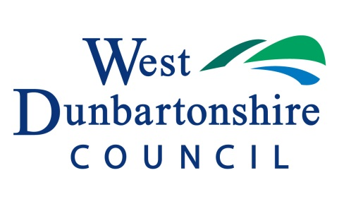

Property Matchmaker
Owner Registration Form
Your details
Name:
Phone: |  |  |  | Email:
Address:
Empty property address
Property details
- Area type: | Town |  |  | Village |  |  |  |  |  | Rural
- Type of property: |  |  | House |  |  |  |  |  | Flat
- Number of bedrooms: |  |  | 1 |  |  | 2 |  |  |  |  | 3 |  |  | 4 | 5 or more
- Style of property: |  |  | Period |  |  |  | Contemporary
- Condition of property: |  |  | Good condition |  |  |  |  |  |  |  |  | Needs minor work |  |  |  |  | Needs major work
- Any garden/land? |  | Yes |  |  | No |  |  | If yes, please give details:
Sale price
Valuation: |  | £ | Asking price: |  | £
Does the property have a current Home Report? |  |  |  | Yes No
Is the property currently for sale on the open market? |  |  |  | Yes No
 | If yes, please provide the name of the agent
Please note that under the Housing Act 2006 it is a legal requirement in Scotland for any property which is “on the market” to have a Home Report.
Owners who are considering selling but have not yet taken the step of getting a home report may register with the scheme, however should not enter into any negotiations with potential purchasers until a Home Report has been acquired.
Additional information/comments/questions (e.g. details of work recently completed or to do, etc)

Code of conduct
The Code of Conduct applies to all parties on the Matchmaker Scheme. The Matchmaker Scheme promotes a suitable and satisfactory outcome for all parties. Communications and negotiations between parties must be respectful, honest and reasonable at all times. Participants must ensure that no action or omission on your part is detrimental to the interests of the scheme.
Please note that failure to meet the standards and requirements of the code of conduct may result in removal from the scheme.

Privacy Policy
By providing your details supplied on this registration application you agree to your information held for the purposes of the Property Matchmaker Scheme. By providing your details supplied on this registration application you agree to your information being shared with registered Property Matchmaker Buyers whose criteria meet your requirements for the purposes of the local property matchmaker scheme.

Your personal details will not be accessible through our website or made public in any other way and any personal information provided will be retained by the relevant councils for the purposes of the property matchmaker scheme until you either find a match to a property or for 12 months from receipt, unless you advise us within that period that you no longer wish to participate in the scheme.

For more information on how West Dunbartonshire Council process personal data or to see how you can exercise your right under the Data Protection Bill 2018 and the GDPR then see West Dunbartonshire Council’s privacy notice at http://www.west-dunbarton.gov.uk/privacy/

When sending personal information you are advised to do so in as safe and secure a manner as possible. Using registered post, hand delivery or special delivery will provide some assurances that we may have received them. If you intend to send information to us you must be aware that email should not be considered a secure method of delivery. The Council accepts no responsibility for the loss, damage or misdirection of personal information, sent electronically or by any other means

By providing your details you agree to your information being shared with potential buyers. Your personal details will not be accessible through our website.
Signature (tick box if filling in electronically):

Please return your completed form to the Empty Homes Officer:
Name: Karen Rae
Address: 16 Church Street, Dumbarton G82 1QL
Tel: 01389 737347
Email: Karen.rae@westdunbarton.gov.uk

What happens next?
The Empty Homes Officer will contact you to arrange a site visit and the property will be added to the property list.
If a potential match is found the Empty Homes Officer will introduce the identified purchaser to the owner and the two parties can then take forward discussions about the sale of the property, either directly or through their agents.
No personal details are made public.

Disclaimers
- The Property Matchmaker scheme is not an estate agency. It does not constitute professional advice or public marketing of your property, and is not a substitute for any legal processes associated with selling and buying property. The Council is not acting as an agent for any party, and all negotiations and sales processes take place between the seller and buyer. It is strongly recommended that all potential sellers carry out their own checks and inspections and independent legal advice is obtained before entering into any contract or other legally binding document.
- It is a legal requirement in Scotland for any property which is on the market to have a Home Report. Owners who are considering selling but have not yet taken the step of getting a home report may register with the scheme, however should not enter into any negotiations with potential purchasers until a Home Report is acquired.

