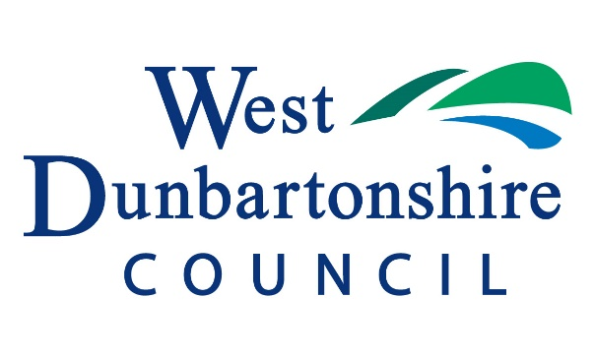

Procedure for monitoring, requesting and allocating developer contributions

June 2022

Procedure for monitoring, requesting and allocating developer contributions
1. The Council’s Planning Service will maintain a database for recording developer contributions. This will record the development site they were received from and the projects they were spent on or are allocated to be spent on.
2. As soon as possible after the end of each financial year, a report will be prepared for the Planning Committee detailing developer contributions received and where they have been spent or are proposed to be spent. This report will relate to funds currently held and projects being or still to be delivered.. This report will also offer the opportunity for the system set out in this paper to be reviewed and for the criteria for identifying eligible projects to be reviewed (for example as set out in “Allocation of developer contributions towards green network and green infrastructure projects”)
3. Any Council service or partner organisation which wishes to make use of the green network/green infrastructure developer contribution fund should have regard to the “Allocation of developer contributions towards green network and green infrastructure projects” paper and make a request for funding by completing the attached project request pro-forma. Requests for use of other types of developer contributions received e.g. commuted sums for parking should also be submitted on the pro-forma. The request will then be considered by the Planning, Building Standards and Environmental Health Manager.
4. Should the project be approved by the Planning, Building Standards and Environmental Health Manager, agreement will be reached on the timing of transfer of funds to the delivery partner.
5. On completion of the project, the delivery partner will be required to submit a project completion pro-forma setting out the final project cost and detailing when the work was physically completed, and the final monetary total for the project. This report will be kept on the Developer Contribution System for that particular project. Any underspend of developer contribution funding will be returned to the developer contribution account, and linked again to the development site from which the contribution was received.

Planning Service Developer Contributions
Project Request Pro-forma
Project Name:
Project Type:
Location:
Community Council area:
Ward:
Locality Planning Area:
Project details:

Estimated total cost:
Amount requested from developer contribution fund:
Other funding sources:

Reasons for developer contributions being required:

Planning Service Developer Contributions
Project Completion Pro-forma
Project Name:
Project Type:
Location:
Community Council area:
Ward:
Locality Planning Area:
Project details:

Total cost:
Project completion date:
Amount received from developer contribution fund:
Amount received from other funding sources:

Amount to be returned to developer contribution fund (if any):

