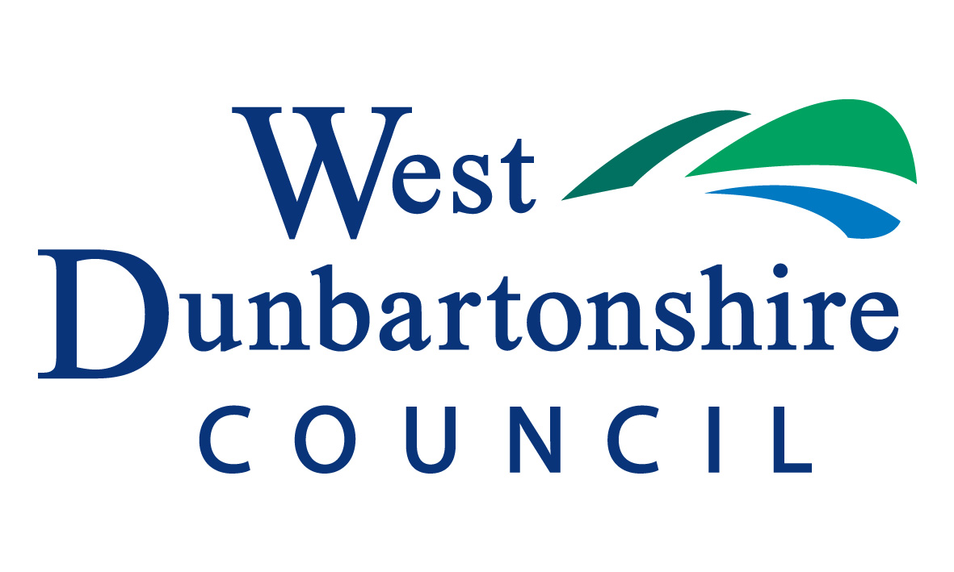
Dumbarton Common Good Fund
Application Form

Please read the Information Notes before completing this application form
Tell us about who is applying for funding
1. Name of the Organisation
Name:

Contact details
Name: |  | Surname:

Organisation Address Details
Post code:
Phone: (daytime)
Email address:
2. Please describe your organisation, (please tick):
A not-for profit constituted Group | A charity | Other
If other, please specify

If a charity, what is the registration number given to your organisation by the Office of the Scottish Charity Regulator?
Registration number:

3. What area does your organisation cover?

4a. How many active members are involved in your organisation?

4b. How often does your organisation meet?

4c. Where does your organisation meet?
4d. When was your organisation started?

5. Where appropriate - have all volunteers/ staff in your organisation been checked through Disclosure Scotland?

If your staff and/or volunteers are working with children and/or vulnerable adults have they been suitably investigated, and their fitness for their duties properly established via appropriate Disclosure checks?

6. What are your organisation’s main aim/ activities?

Tell us briefly what your group does.

Tell us what the money is for.

7. What will your organisation use the money for?

Please explain what the project involves and how it be implemented. Is this type of project something new for your group or is it something similar to what you’ve done before?
8. What other grant funding has your organisation applied for in the last 12 months and what other grants do you plan to apply for in the coming 12 months?

 | Please list all grant applications. Please use another sheet if necessary.
Name of grant, Funding Body, is the grant general or for a specific project? |  | Total amount applied for | Date of Application | Result
 |  | £
 |  | £

Tell us how much money you need for your project.
9a. Please give us a breakdown of ALL costs for your project and tell us how much you are requesting from us. (Please include VAT where applicable)
Please list all the items or activity associated with your project. You should list all costs even if you are not asking to fund all the items. Please use another sheet if necessary. If you have any quotations or more details about how you worked out your costs, please send this information to us with your application.
Item or activity | Total Cost  (including VAT) | Amount requested from Common Good Fund
 | £ | £
 | £ | £
 | £ | £
 | £ | £
TOTAL | £ | £

9b. If the total project cost is more than the amount you are asking for, please tell us where the rest of the money will come from e.g. other funders, ticket income, fundraising, group funds, etc.
Tell us if you are applying to any other organisation for this project, and what stage your application has got to. Also tell us about income you think your project will make and any money your group is contributing.
Source | Amount | Progress
 | £
 | £
 | £
TOTAL | £ | £

9c. Please tell us about any non financial contributions your organisation is making to this project. (This can include “in-kind” contributions, such as volunteers’ time or the use of a building)

10. How does/will the project benefit the Dumbarton area or residents? Who will it benefit? How many are likely to benefit?

Explain who will benefit and in what way e.g. young people, older people, disadvantaged groups.

11. Are you planning on buying equipment with the funds? YES/NO.

If purchase of equipment is planned:

Where will the equipment be kept?
Name the person who will be responsible for the equipt?
What security measures have been taken for the equipt?
Does your organisation have insurance cover for the equipt?

12. Do you have any other information you think is relevant to the application?

13a. Please give us your bank account details.

You must send an original bank statement with this application. We will return this to you.
If you have a passbook account, you can send a copy of the pages of your book.
Account name
Bank or building society name
Bank or building society address
Sort code
Account number:
Roll number

13b. Is this your only bank account/ building society account? YES/NO

13c. If NO, please provide details of other accounts – including current balance

14a.What is your financial year?

14b. Are your Financial Statements audited? YES/NO

14c. If NO, why?

14d. If YES, who are your auditors?

15. Authorisation

I confirm that, as far as I know, all the information on this application form is true and correct. I understand that you may ask for more information at any stage of the application process.
(Note: This must be same person as the one in question 1)
Name: |  | Date:
Position held in your group:

15. Details of your Chairperson, Vice Chair, Secretary or Treasurer.
Position in group:

Title | First name: |  |  | Surname:
Signature:

What to do now
Before you send us your application, check that you have done everything.
Check that you have enclosed all the documents we need:-

- A copy of the constitution or set of rules that your group has adopted.
b. Your most recent yearly accounts or statement of income and spending.
c. A document giving us proof of your group’s bank or building society account. This document could be:-
- a copy of your most recent bank statement in the name of your group
- a copy of your building society passbook, with the pages showing your group’s name, account number and current balance; or
- if you’re a new group who has only just set up your account, a signed letter from your bank or building society on their headed paper. This letter must show your account name, number and sort code.

Now send your application with all the documents to:

- Grants Administrator
West Dunbartonshire Council
Resources Services
16 Church Street
Dumbarton
G82 1QL
- Or by Email to: Trusts.specificgrants@west-dunbarton.gov.uk

