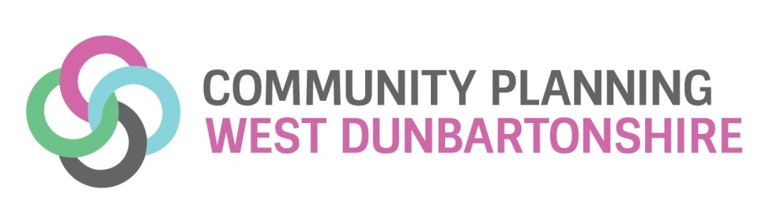

Appendix B

Community Justice Outcome Improvement
Action Plan 2017-2018

National Community Justice Strategy Section 4
Improved public understanding and participation in community justice

West Dunbartonshire Community Justice Outcome 1:
Improve public understanding and participation in community justice
Action | Action Due Date | Managed By
Establish community justice consultation areas to embed within CPWD Your Community model, supporting capacity building  Develop and agree local indicators to be utilised to monitor progress within the new Community Justice model  Develop an improved shared understanding of local community justice issues and what effective interventions can be delivered to provide opportunities for change  Identify ways that we can improve communication, learning and innovation to secure better outcomes for our citizens and communities  Ensuring community justice is a key element of consultation, engagement and involvement for key partners | 31 March 2018 | West Dunbartonshire Community Justice Partners

West Dunbartonshire Community Justice Outcome 1
Performance Reporting Indicators

Indicator Type | Indicator | Reporting Measure
Quantitative | Perceptions of local crime rate | West Dunbartonshire results from Scottish Government Household Survey
Contextual | Public attitudes to crime and other issues that impact on communities | West Dunbartonshire findings from Police Scotland Your View Counts survey/West Dunbartonshire Citizens Panel findings
Change and Impact | Activities carried out to engage with ‘communities’ as well as other relevant constituencies | Community Justice specific activities and results/outcomes of work undertaken in the development of West Dunbartonshire’s refreshed Community Engagement and Participation Model including:  People with convictions  Victims of crime  Wider Community of Residents  Business Community
 | Consultation with communities as part of community justice planning and service provision | Links between local police plans, Your View Counts and those for other partners and how they link to community justice  Specific consultation to identify the needs of the local community including meeting needs of underlying causes of offending and the knock-on impact to meeting broader community justice outcomes

National Community Justice Strategy Section 5
Strategic Planning and Partnership Working
West Dunbartonshire Community Justice Outcome 2:
Improve community justice strategic planning and partnership working
Action | Action Due Date | Managed By
Establish Community Justice priorities within the Delivery and Improvement Group structure to oversee implementation in 2017-2018  Improve our understanding, planning and service delivery to maximise opportunities for prevention and early intervention to reduce offending and re-offending  Develop a framework and structure for involving those with a history of or affected by offending in the planning and delivery of community justice services  Identify opportunities to build the community justice evidence of CPWD partners contribution  Help workforces understand how they, and other partners, contribute to community justice outcomes  Build effective links with children’s services planning  Support and assist the development of strong multi-agency public protection arrangements (MAPPA)  Develop community justice outcomes, performance and improvement reporting framework and self-evaluation  Contribute to the development of the Community Justice Scotland Strategy for Innovation, Learning and Development | June 2017  March 2018 | West Dunbartonshire Community Justice Partners  West Dunbartonshire Community Justice Partners

West Dunbartonshire Community Justice Outcome 2
Performance Reporting Indicators

Indicator Type | Indicator | Reporting Measure
Change and Impact | Services are planned for and delivered in a strategic and collaborative way | Evidence of effective partnership working, e.g. from self-evaluation
 |  | Evidence of involving communities, including those with a history of or affected by offending, in the planning and delivery of community justice services
 |  | Evidence of planning for joint delivery around prevention and early interventions
 |  | Evidence of effective planning for transitions for children and young people who may need access to community justice services as well as planning for those who transition into adult services
Change and Impact | Partners illustrate effective engagement and collaborative partnership working with the authorities responsible for the delivery of MAPPA | Evidence that strategic planning and reporting mechanisms for improved community justice outcomes has considered people subject to MAPPA
 |  | Evidence of joint training/awareness sessions
 |  | Evidence of collaborative risk management planning

National Community Justice Strategy Section 6
Equal access to services
West Dunbartonshire Community Justice Outcome 3:
Improve access to community justice services
Action | Action Due Date | Managed By/Lead
Develop a consistent approach to the engagement with the children and families of people who have committed offences  Support the development of effective mentoring and “through-the gate” models developing a collaborative model that:  Promotes health improvement opportunities  Facilitates the early assessment of individual housing need  Improves access to financial and welfare advice services  Promotes employment opportunities | 31 March 2018 | West Dunbartonshire Community Justice Partners

West Dunbartonshire Community Justice Outcome 3
Performance Reporting Indicators

Indicator Type | Indicator | Reporting Measure
Change and Impact | Partners have identified and are overcoming structural barriers for people accessing services | Improved understanding of barriers to employment, training and education as a result of previous convictions. Identified improvement actions for 2018-19
 |  | Improved understanding of barriers to financial and welfare services as a result of previous convictions. Identified improvement actions for 2018-19
 |  | Improved understanding of barriers to health services as a result of previous convictions. Identified improvement actions for 2018-19
 | Existence of joint-working arrangements such as processes/ protocols to ensure access to services to address underlying needs | Joint working arrangements exist to ensure access to appropriate services at all points of the criminal justice pathway. Identified improvement actions for 2018-19
 | Speed of access to mental health services | 90 per cent of patients commence psychological therapy based treatment within 18 weeks of referral, recognising that the data will include the whole community
 | Speed of access to drug/alcohol services | 90 per cent of clients will wait no longer than 3 weeks from referral received to appropriate drug or alcohol treatment that supports their recovery, recognising that the data will include the whole community
Quantitative | Access to services on release from prison  % of people released from a custodial sentence who are  - Registered with a GP  - Have suitable accommodation  - Have had a benefits eligibility check | A range of partner input requirements will begin to build this new indicator, progress to date reporting measure

National Community Justice Strategy Section 7
Effective Use of Evidence-Based Interventions
West Dunbartonshire Community Justice Outcome 4:
Improve understanding and use of community justice evidence-based interventions
Action | Action Due Date | Managed By/Lead
Capitalise on third sector interventions  Develop and review the evidence base to scope for areas for improvement in community justice early intervention and diversion  Collaborate with local Alcohol and Drug Partnerships to scope, review and monitor the effectiveness of interventions for drug and alcohol use | 31 March 2018 | West Dunbartonshire Community Justice Partners

West Dunbartonshire Community Justice Outcome 4
Performance Reporting Indicators

Indicator Type | Indicator | Reporting Measure
Change and Impact | Use of “other activities requirements” in Community Payback Orders | Involvement of other partners in the other activities requirements, identification of improvements for 2018-2019
 |  | Examples of creative and innovative use of the other activities requirement such as attending college or training course, resilience training, engaging with a specific needs-focussed service with another partner
Quantitative | The delivery of interventions targeted at problem drug and alcohol use | Progress towards developing indicators:  Number of referrals from criminal justice sources to drug and alcohol specialist treatment  The number of alcohol brief interventions (ABIs) delivered in criminal justice healthcare settings

West Dunbartonshire Community Justice Outcome 5:
Individual has made progress against outcomes:
- Life chances are improved through needs, including health, financial inclusion, housing and safety being addressed
- People develop positive relationships and more opportunities to participate and contribute through education, employment and leisure activities
- Individuals resilience and capacity for change and self-management are enhanced

Action | Action Due Date | Managed By/Lead
Gather evidence and baseline the current processes and methods of Community Justice Partners to monitor outcomes at an individual level | 31 March 2018 | West Dunbartonshire Community Justice Partners

West Dunbartonshire Community Justice Outcome 5
Performance Reporting Indicators

Indicator Type | Indicator | Reporting Measure
Change and Impact | Individuals have made progress against the outcome | How do Community Justice Partners know that service interventions are assisting individuals to achieving their goals

