TP Update what’s new in Tenant Participation Summer 2021
https://www.west-dunbarton.gov.uk/housing/council-housing/tenant-participation

Jane Mack: 07983 542993

Hanne Thijs: 07823 664247
jane.mack@west‐dunbarton.gov.uk
hanne.thijs@west‐dunbarton.gov.uk

Welcome

Welcome to the TP Summer update. Its purpose is to keep our Tenant & Resident Associations, interested tenants, Scrutiny Panel members, Sheltered Forum members, Council staﬀ and Elected Members up‐to‐date with TP events and developments.

TP update
Since the last TP update in the Spring, staﬀ, tenants and residents have been continuing to work through the impact of Covid as well ensure that the everyday functions of the council are working as they should.

Tenant groups are slowly starting to meet in person, in line with Scottish Government guidelines. Meeting in person works better for some people, but we will work with groups to make sure that there is a virtual option for those who want it.

In‐Person meeting

For groups meeting in person we are advising following Scottish Government advice as it relates to West Dunbartonshire. Even as restrictions ease, we will continue to suggest groups make hand sanitiser available, ensure there is space between attendees, open windows and doors for airflow if possible and check attendees don’t have Covid symptoms before the come in to the meeting.

If any group wants more details you can contact Hanne on 07823 664 247 or hanne.thijs@west‐ dunbarton.gov.uk

Recruitment
Many of our groups are working hard to recruit new members.
There are many ways to do this including flyers, leaflets and social media posts.

It seems that simple is often the most eﬀective , for example, chatting to people informally. If everyone has a wee chat with someone, we will soon have more people involved.

Joint Rent Group
The Joint Rent group are meeting regularly via Zoom. They created an action plan based on the assessment of compliance with the HRA Guidance and are working to ensure that the Council fully meets the Guidance. Hats oﬀ to them as they are really getting into meaningful financial discussions that all tenants will benefit from. The group are also committed to ensuring tenants are more involved ahead of the rent setting consultation to ensure that tenant spending priorities are considered.

Tenant Priority Budget
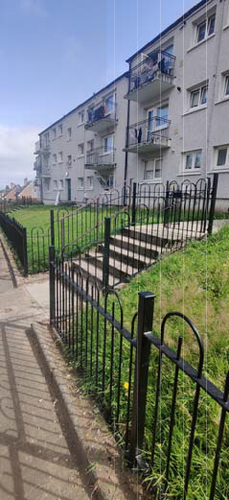
The Tenant Priority Budget has been available for the entirety of the pandemic, however up‐ take has been low and restrictions limited what work could be carried out. As we move forward, we are starting to get some more suggestions for projects including repainting of railings and garages. There are some bigger projects which are being worked on, including laundry rooms for some of the high rise flats. Some projects have
been completed, including putting railings in at Craigielea Road (pictured). If you have any suggestions please get in touch with Hanne.

Scrutiny Panel

The Scrutiny Panel are coming towards the end of their current scrutiny exercise looking at the complaints procedure. They are currently writing up their report with observations and recommendations. If anyone wants to get involved with the Scrutiny Panel now would be a good time and training and support would be provided before they start their next scrutiny exercise. Please contact Jane if you’re interested.

Working together
Central Alexandria Tenants and Residents Association (CATRA) have been working with Food for Thought
through the pandemic by providing a base for the charity in Alexandria. Many of our groups find benefits in working closely with other charities to deliver services in the local community. It is also a way to promote the benefits of tenant participation to new people.

Staff and tenants are encouraged to use the Housing News which gets delivered to all tenants—share your news or let us know if there is information you would like to see included

Housing News dates
Autumn edition
Deadline for articles | 13.8.2021
Expected delivery date | 28.09.2021
Winter edition
Deadline for articles | 22.10.21
Expected delivery date | 7.12.2021

TP Strategy
The Tenant Participation Strategy 2021‐24 is available online—https://www.west‐ dunbarton.gov.uk/council/strategies‐plans‐and‐ policies/housing/tenant‐participation‐strategy/
and gives you information on all the diﬀerent ways tenants can get involved and make a diﬀerence as well as the support available to do so—please have a read. If you want a paper copy please get in touch.

