|  |  |
| --- | --- |
| **UK Shared Prosperity Fund**  **Shopfront Improvement Grant** | **WDC logo colour** |
| **Eligibility & Guidelines** |

1. **General information**

**Attractive shopfronts make Town Centres more welcoming and attractive places for people to shop, visit for leisure and enjoy. The West Dunbartonshire Shopfront Improvement scheme aims to:**

* **Help existing landlords and tenants improve the quality and appearance of commercial units.**
* **Increase the attractiveness of shop units within the Town Centres.**

The Shopfront Improvement Grant is fully funded through the UK Shared Prosperity Fund and it will provide up to a maximum of £10,000 toward shop front improvement works for businesses located within the town centres of Alexandria, and Clydebank. The first round of funding was piloted in the Town Centre of Alexandria, and has now been expanded to the town centre of Clydebank. This information pack aims to help applicants establish whether they are eligible to apply for grant support through the scheme, The guidance seeks to help steer applicants through the process, from initial contact with the Council to final payment of the grant.

The property for which the grant is sought must be a commercial property which is present on the Scottish Assessors Office business rates register.

* 1. **Value of the Grant**

The Grants will be up to a maximum value of £10,000 and works up to a value of £12,000 are eligible.

Additional funding will be available for business located in Listed Buildings or within a Conservation Area. For such businesses Grants will be able up to a maximum of £20,000 with an applicant’s contribution remaining capped at £2,000

For all applications the first £2,000 of the value of the works will be 100% funded by the grant. The costs between £2,001 and £12,000 will be 80% funded by the grant. Costs above £12,000 will not be eligible for grant support unless they are related to a property located in a Listed Building or a Conservation Area. The table below provides some examples of cost breakdowns for different values.

|  |  |  |  |
| --- | --- | --- | --- |
| **Application Value** |  | **Grant £2000 + 80% of the remaining costs** | **Applicant contribution** |
| **£    1,200.00** |  | **£1,200 + £0** | **£ 0** |
| **£    2,000.00** |  | **£2,000 + £0** | **£ 0** |
| **£    5,000.00** |  | **£2,000 + £2,400** | **£  600.00** |
| **£  10,000.00** |  | **£2,000 + £6,400** | **£ 1,600.00** |
| **£  12,000.00** |  | **£2,000 + £8,000** | **£ 2,000.00** |
| **£  12,500.00** |  | **£2,000 + £8,000** | **£ 2,500.00** |
| **£ 15,000.00** |  | **£2,000 + £8,000 (+£3,000 Conservation Grant)** | **£ 2,000.00** |
| **£ 18,000.00** |  | **£2,000 + £8,000 (+£6,000 Conservation Grant)** | **£ 2,000.00** |
| **£ 20, 000.00** |  | **£2,000 + £8,000 (+£8,000 Conservation Grant )** | **£ 2,000.00** |
| **£ 21,000.00** |  | **£2,000 + £8,000 (+£8,000 Conservation Grant)** | **£ 3,000.00** |
|  | | | |

* 1. **Timescale**

The grants will be available until March 2025 however the scheme will be closed early once funds are fully allocated.

* 1. **Eligible works**

The quality and appearance of buildings in the Town Centre are very important and have a considerable impact on the overall attractiveness of the area. The grant aims to improve the appearance of the town centre and make it more attractive for shoppers and visitors at any time of the day.

The Grant will only fund what are called ‘eligible works’. Whether the works are eligible will be at the discretion of the Council. The Grant aims to achieve high quality results and some works will not be supported, for example installation of some types of external roller shutters and signage. If in doubt, the businesses are encouraged to get in touch to discuss their proposal prior to submitting the application.

The following list provides a guide for what can and can’t be funded.

|  |  |
| --- | --- |
| **Eligible** | **Not Eligible** |
| * Restoring traditional features i.e. fascia * Pipes and gutters * Re-pointing of brickwork * Woodwork/brickwork * Re-render and re-paint * Window frames and glazing * Signage upgrades * Security works e.g. security gates & locks and shutters which complement the appearance. | * Internal works * Rooftop repairs * Insurance, rent & business rate costs * VAT costs * Externally mounted full roller shutters * Some types of off-the-shelf facia or window signage * Oversized fascias being used to conceal a suspended ceiling inside the shop |

The shopfronts should respect the character of the street and the area in general, and be harmonious with the overall style and appearance of the building. Any proposed colour scheme should be in keeping with the existing colour scheme of the building and the adjoining buildings.

If the property/business is located in a Listed Building or in a Conservation Area, all relevant consents must be obtained.

* 1. **Eligible business Areas**

The grant is aimed mainly at small independent businesses. Within the Main towns of West Dunbartonshire (Larger Maps available within the Appendix)

|  |  |
| --- | --- |
| **Alexandria** |  |
|  |  |
| **Clydebank** |  |

1. **Applying for the grant**

The Application form can be downloaded from: <http://www.west-dunbarton/business/grant-and-loan/>

To receive an application form in a paper form or to receive additional information, please contact the Regeneration Team at West Dunbartonshire Council via Email: [regeneration@west-dunbarton.gov.uk](mailto:regeneration@west-dunbarton.gov.uk)

The following are the key stages of the application process.

|  |  |  |
| --- | --- | --- |
| **Stage 1 - APPLICATION** | **Stage 2 – GRANT OFFER** | **Stage 3 – STATUTORY CONSENT** |
| Applicant submits an  Application. | Council assesses application and notifies the applicant about the decision.  **3 weeks** | If required applicant secures all relevant permissions |
| **Stage 4 – CLAIM** | **Stage 5 - ASSESSMENT** | **Stage 6 - PAYMENT** |
| Applicants notifies the Council that the work/stage has been completed and submits the claim. | Council processes the payment claim  **2 weeks** | Applicant receives the grant. |

Prospective applicants are welcome to arrange a pre-application consultation with the Regeneration team. Please get in touch by email [regeneration@west-dunbarton.gov.uk](mailto:regeneration@west-dunbarton.gov.uk).

**2.1 Stage 1 - Application**

The Applicant submits the Form to [regeneration@west-dunbarton.gov.uk](mailto:regeneration@west-dunbarton.gov.uk).

For works with a value of **over £2,000** three comparable quotations will be required. This is to evidence the market value.

For works that are **under £2,000** only one quote will be required to proceed. The Council reserves the right to assess whether the quote represents the best value.

Example:

An application for £6,100 covers replacement signage and widows. (£1,300 for signage and £4,800 for widows). It can be split into two different work packages:

|  |  |  |
| --- | --- | --- |
| **Item** | **Value** | **Requirement** |
| Signage | £1,300 | Under £2,000 (only 1 quote required) |
| Windows | £4,800 | Over £2,000 (an additional 2 quote will be required to approve) |

In this example only one quotation for signage would be required, as it is under the £2,000 threshold, however additional two quotations for widows would be required to allow this element of the work to proceed.

It is recognised that sometimes it can be difficult to secure 3 quotations. In this situation it will be at the discretion of the Council to accept evidence of attempts to secure quotation, such as emails to companies inviting them to quote.

VAT costs are excluded from grant support, as most business can claim this back via their business accounting.

The Applicant must be able to provide the following details if requested:

* **Ownership details**: If the applicant does not own the property, it is the applicant’s responsibility to ensure that they have the owner’s permission to carry out the works.
* **Description of the works:** This must include a ‘schedule of works’ describing the proposed work together with a breakdown of the estimated costs.
* **Timescale:** An approximate idea of when the work will take place and when it will be completed.

**2.2 Stage 2 – Grant Offer**

The Council will assess the application and issue a Grant Offer letter. The Grant offer will state the amount of money the Council will offer the applicant under the grant scheme. It will be calculated based on the value of the quotations provided. In all cases the grant offered will not exceed £10,000. Unless connected to a listed building or conservation area.

If any of the proposed works are not eligible for funding, the Council will invite the applicant to discuss alternative solutions and submit a revised proposal.

**2.3 Stage 3 – Statutory Consents (if applicable)**

Some works may require approvals, permissions, consents, or licences. It is the Applicant’s responsibility to secure all statutory consents. The Council will be unable to release any grant funds until the applicant provides evidence confirming that all relevant approvals, permissions, consents, and licences have been obtained and granted. Cost of a professional advisor, such as an Architect, will be eligible for grant support, and will be included in the overall value of works. It is advised that for larger schemes professional advice is sought.

The following is a list of what may be required prior to starting work on site.

* Planning permission – may be required, depending on the extent and nature of the proposed works.
* Conservation & Listed Building Consents - if your business is located within a Conservation area or in a listed building, you may need Conservation Area Consent or a Listed Building Consent for your proposed work.
* Advertising Consent - may be required for new fascia or hanging signs.
* Building Warrant - may be required for some works. It can take two months or more to determine a building warrant application, depending on the nature of the works. Applicants need to build this into their timetable.

Safety inspections and/or certificates – may be required, depending on the extent and nature of the proposed works. Any works requiring safety inspections and / or certificates must be carried out by an appropriately qualified professional.

**2.4 Stage 4 – Claim submission**

When applicants submit a claim for the grant funds, the claim must be accompanied by the following evidence:

* Confirmation that all works claimed for have been completed
* A breakdown of the costs of the works claimed for including VAT as a separate item.
* The total price for the works including VAT as a separate item.
* Evidence of the contractor’s formal invoice to the applicant.
* Confirmation that all relevant approvals, permissions, consents and licences have been obtained and granted.

For higher value contracts there is an option of staged payments of the grant.

Photographic evidence will normally be sufficient to confirm the completion of the works however a site visit may also be requested by the Council.

**2.5 Stage 5 – Claim assessment**

The payment of the grant will be approved on receipt of the contractor’s formal invoice, and of confirmation that all works/agreed stages have been completed.

Invoices should contain contact details of the contractor, their registered address, and Vat Registration number.

No cash in hand payment should be made, as an audit trail of public funds must be transparent.

We reserve the right to withhold the payment if correct evidence cannot be provided.

**2.6 Stage 6 - Payment**

The Council will endeavour to pay the grant as soon as possible after works are completed. It will be the applicant responsibility to ensure they have provided correct account payment details. The form for this will be provided along with the Grant Offer letter.

To help the Council process the claim efficiently and avoid delays, applicants should respond promptly to any requests for information.

1. **Conditions of the Grant**

Once the grant is approved the applicant company must confirm acceptance of the terms and conditions of the grant within 4 weeks of approval.

Approval of the Grant is at the sole discretion of Council Officers and will only be given when all conditions have been met and detail of eligible spend has been agreed.

Successful applicants will be required to report on outputs and outcomes in alignment with the objectives of this grant. The grant must be fully claimed within 6 months of approval.

The Council reserve the right to recover misused funds and may, at its absolute discretion, withhold further instalments which were to have been made, or may cancel completely the payment of any further sums to the Organisation.

West Dunbartonshire Council is committed to sharing good practice and promoting examples of service delivery that meet the needs of communities. The Council reserves the right to use details of the project for publicity for the programme and share information with any parties appointed to monitor and evaluate the effectiveness of this funding.

The Council may be required to make any application or project proposal for this funding available for public scrutiny under the Freedom of Information (Scotland) Act 2002. The applicant should make the Council aware of any parts of its application or project proposal, which may prejudice its interest if it were made public.

**3.1 Awarding Grants Criteria**

Five criteria are taken into account when applications are being considered. These are:

* **The Right Offer**

The Council is seeking applications from owners, agents & businesses who are offering proposals that will add value to, and enhance both the vitality and viability of the Town Centre area.

* **Geographic Area**

The scheme is initially available for units located in Alexandria Town Centre.

* **Viability**

Applications must show a commitment to the ongoing use of the property. Applications from businesses on short term lets, such as pop-up shops cannot be supported, however the landlords can apply.

* **Appearance**

The Grant aims to improve the appearance of shopfronts. Physical appearance is important to make the Town Centre more attractive to visitors, shoppers and investors.

* **Value for Money**

As the Grant is from public funding, the Council must ensure value for money. Applicant must submit evidence of at least three quotes to allow the Council to calculate the value of the grant. The Council reserves the right to have the cost estimate assessed by an independent cost consultant.

**3.2 Terms and Conditions**

The Grant offer forms a contract between the applicant and the Council. If the applicant decides to accept the grant offer and agree to abide by the conditions contained in the offer, they must confirm this by signing two copies of the grant offer and returning one to the Council. It is important that applicants keep a copy of the signed grant offer.

Applicants must take particular care to note all of the grant conditions as they could put the grant offer at risk if they are not met.

**3.2.1 Grant offer duration**

The Grant offer will remain available for a period of 3 months or as shown in the offer letter. The work must be underway within the period stated in the offer, unless otherwise agreed.

**3.2.2 Council’s liability**

No liability lies with the Council (as project sponsor) in the event of claims against the grant recipient. The Council accepts no responsibility for any professional advice offered by its representatives.

**3.2.3 Applicant’s liability**

Any work commenced prior to the Applicant receiving the grant offer and formally accepting the offer and conditions, are done at the Applicant’s risk and may not be funded by the grant. In such case the Applicant will be liable for all the costs incurred.

**3.2.4 Insurances**

Building owners and tenants are advised that they must inform their building insurers about their proposals to carry out works. The applicant must also ensure that all contractors on the project have their own insurance to cover any risk (e.g. public liability) during the building works.

**3.2.5 Health and Safety**

Applicants will be responsible for carrying out work in line with Current Health and Safety Requirements.

**3.3.6 Changes to the Agreed Scheme**

If applicants wish to make any changes to the proposals after the grant offer letter has been signed, the applicants must inform the Council in writing prior to undertaking the changes. The Council will then inform the applicant whether or not the proposals are considered to be acceptable under the agreed scheme and the Council reserves the right to withdraw the grant offer.

**3.3.7 Monitoring**

Occasionally, both during and after completion of your improvement works, the Council may ask the applicant to supply information about the project.

**3.3.8 Subsidy Control – Minimal Financial Assistance (MFA)**

The UKSPF Shopfront improvement grant is classified as a Minimal Financial Assistance (MFA) subsidy under the [Subsidy Control Act (2022).](https://www.legislation.gov.uk/ukpga/2022/23/enacted)  To be eligible for the support, you **must not** have already exceeded receipt of £315,000 in MFA subsidies over this and the previous two financial years.

***Note: Minimal Financial Assistance (MFA) is a relatively new term which you may have previously seen referred to as “De Minimis” or “Special Drawing Rights” (SDR).***

Before making any payment, written confirmation that receipt of the payment will not exceed your company’s MFA threshold of £315,000 cumulated over this and the previous two financial years, as specified in section 36(1) of the Subsidy Control Act (2022), is required.

This means you must confirm you have not received more than **£315,000 minus the value of this grant** in MFA subsidies or comparable types of subsidy (see section 42(8) of the Subsidy Control Act (2022)) in the current or previous 2 financial years.

We take this opportunity to remind you that you are required to keep a written record of the amount of MFA you have received and the date/s when it was received. The written record must be kept for at least three years beginning with the date on which the MFA was given. If your application is successful at the point of claiming the grant, we will issue you with an email which you can use as your written confirmation. This will enable you to respond to future requests from public authorities on how much MFA you have received and whether you have reached the cumulative threshold.

1. **How to Apply:**

Complete the West Dunbartonshire Shopfront Improvement Grant application form and submit it with the following enclosures:

* Evidence of Quotes provided
* Proof the applicant has the authority to undertake works to the commercial property.

To receive an application form or to receive additional information, please contact the Regeneration team at West Dunbartonshire Council on:

Telephone: 07789 018112 or Email: [regeneration@west-dunbarton.gov.uk](mailto:regeneration@west-dunbarton.gov.uk)

Website: <http://www.west-dunbarton/business/grant-and-loan/>

Appendix A (Alexandria)

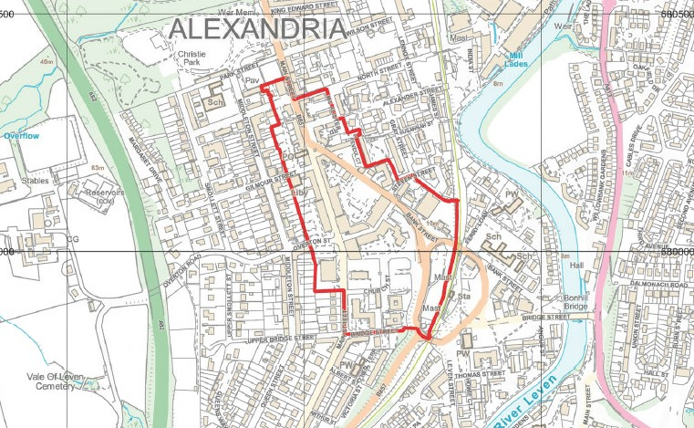

Appendix B (Clydebank)

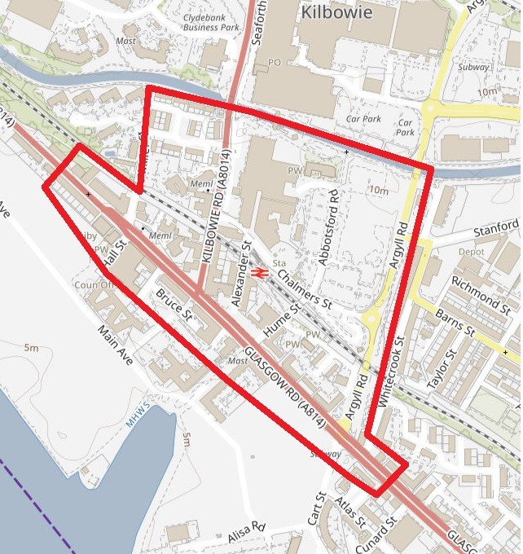

**This project is funded by the UK government through the UK Shared Prosperity FunD**

|  |  |
| --- | --- |
|  |  |