

West Dunbartonshire

Anti-Social Behaviour Strategy

2024 - 2027

Table of Contents

1. Introduction 2

2. Aims and Objectives 3

3. Legal Framework 5

4. Partners and Services who work to Reduce and Enforce Anti-Social Behaviour in West Dunbartonshire 6

5. Consultation 18

6. Communication 20

7. Performance Monitoring 21

# Introduction

Feeling safe and secure in your home and community is extremely important and directly affects the cohesion and stability of local communities. Overall, our communities are good, safe places to live, but there are localised instances of anti-social behavior (ASB) or criminal behaviour that adversely affects our resident’s feelings of safety, the quality of the environment and their ability to peacefully enjoy their homes.

The Anti-Social Behaviour Etc (Scotland) Act 2004 (“the 2004 Act”) was introduced to tackle anti-social behaviour in all communities in Scotland.

According to the Act anti-social behaviour can be defined as;

'Antisocial' means causing or likely to cause alarm, distress, nuisance or annoyance to any person or causing damage to anyone's property. Harassment of a person includes causing the person alarm ordistress. Conduct includes speech and a course of conduct must involve conduct on at least two occasions.’

One of the principal requirements of the Act is for the local authority, the Chief Constable of Police Scotland and appropriate partners to jointly prepare an Anti-Social Behaviour Strategy outlining how anti-social behaviour will be tackled locally.

The strategy should set out:

* The extent and nature of anti-social behaviour in the Council area;
* The services already available for preventing and tackling them;
* The new services that the Council and other agencies will need to put in place to fill any gaps in provision; and
* How the Council and the Police will co-ordinate their functions and exchange information.

West Dunbartonshire Council, Police Scotland and our partners believe that all residents and visitors of West Dunbartonshire are entitled to live safely without fear of harassment and nuisance.

Whilst overall incidents of antisocial behaviour reported to both West Dunbartonshire Council and Police Scotland havereduced, partners acknowledge that antisocial behaviour has a negative impact on the lives of our residents and can have a serious impact on communities within our authority.

This strategy will demonstrate how we will work towards reducing anti-social behaviour, take enforcement action where appropriate, and do all we can to prevent the various types of anti-social behaviour from occurring in the first place to deliver better outcomes for all our residents.

# Aims and Objectives

By establishing this strategy, our commitment is to:

* Reduce anti-social behaviour in West Dunbartonshire.
* Work to prevent anti-social behaviour.
* Protect communities.
* Empower communities.
* Better co-ordinate Council and Partner services.
* Provide positive activities for young people.
* Integrate our services.
* Increase use of legislative powers where appropriate
* Provide a coordinated and effective response to the effect of anti-social behaviour in West Dunbartonshire.
* Communicate a “Zero Tolerance” message of anti-social behaviour.
* Assign clear responsibility for dealing with anti-social behaviour.
* Provide education and diversionary activities to break offending behaviour.

The strategy aims are:

1. To promote a safe and attractive West Dunbartonshire (in which people want to live and work).
2. To work with local communities to determine priorities and actions (and help increase confidence among communities that effective action will be taken)
3. To work to prevent and reduce anti-social behaviour by looking collectively at the root causes of anti-social behaviour.
4. To minimise the impact of anti-social behaviour through support for victims and witnesses.
5. To achieve effective joint working amongst partners through improved information and resource sharing.

“Working Together to Prevent Antisocial Behaviour in Scotland” (2009) is the Scottish Government’s national framework for tackling antisocial behaviour.

The framework introduced four pillars to respond to antisocial behaviour which are Prevention, Integration, Engagement and Communication. Key to achieving the aims of the prevention pillar was an update to a PIER (Prevention, Early Intervention, Enforcement and Rehabilitation) model as introduced in national guidance in 2004.

The Promoting Positive Outcomes document defined the components of the PIER model as:

* **Prevention**: requires foresight and planning in terms of putting measures which are likely to create a physical and social environment where antisocial behaviour is less likely to arise. Such measures can start before the antisocial behaviour is evident through a programme of proactive elements such as CCTV and a strong focus on education, support, community engagement and the creation of strong sustainable family environments.
* **Intervention**: Early and effective intervention includes putting in place measures that will help to address problems at the earliest opportunity both in relation to individuals and communities. A variety of approaches and services from a range of statutory and voluntary agencies are needed to provide the choices and chances required to offer opportunities to divert people away from antisocial behaviour.
* **Enforcement**: Enforcement should be considered when effective interventions have been tried, failed or deemed not appropriate. Enforcement requires to be appropriate, proportionate and timely and supported by intervention, education, support and rehabilitation.
* **Rehabilitation**: There is a need to understand and assess the needs of individuals and communities in order to provide long-term solutions. An understanding and perception of the impact of ASB is necessary to fully break the cycle of offending and to provide the focus for services to fully integrate to deliver long-term solutions.

# Legal Framework

West Dunbartonshire Council will work within our statutory powers when tackling anti-social behaviour in West Dunbartonshire. Our statutory powers and duties include but are not exclusive to the following legislation:

* Housing (Scotland) Act 2014
* Housing (Scotland) Act 2010
* Housing (Scotland) Act 2001
* Anti-Social Behaviour (Scotland) Act 2004
* Local Government in Scotland Act 2002
* Civic Government (Scotland)Act 1982
* Criminal Justice (Scotland) Act 2003
* Human Rights Act 1998
* Equality Act 2010
* Data Protection Act 2018
* Public Order Act 1986 Section 18
* Protection from Harassment Act 1997
* Environmental Protection Act 1990
* Dangerous Dogs Act 1991
* Dog Fouling (Scotland) Act 2003
* Control of Dogs (Scotland) Act 2010

# Partners and Services who work to Reduce and Enforce Anti-Social Behaviour in West Dunbartonshire

The term anti-social behaviour means different things to different people. We have aimed to address many areas that are deemed to be anti-social. Anti-social behaviour is any behaviour that adversely affects quality of life, as well as behaviour that causes, or is likely to cause, alarm or distress. This includes but, is not exhaustive to the following:

* Dog fouling;
* Dumping rubbish and litter;
* Threatening or abusive behaviour;
* Drunken and abusive behaviour.
* Harassment and intimidating behaviour;
* Shouting, swearing and general disorder;
* Noisy neighbours;
* Vandalism, graffiti and other deliberate damage to property;
* Drug misuse; including drug dealing, and street drinking;
* Fly tipping; and
* Abandoned cars.

Working in partnership with a range of agencies across West Dunbartonshire we take a number of approaches to tackle ASB as noted below.

West Dunbartonshire Council operates services that can respond to ASB during daytime and out of hours.

Our Anti-Social Behaviour Team (ASBT) investigate complaints of ASB and have the power to raise action/s to court level, and issue on the spot fines for Dog Fouling (£80), Fly-Tipping (£500) and Litter offences (£100).

This team will also engage with community groups, Housing providers and conduct proactive foot patrols in our communities for deterrent and reassurance purposes. The team work very closely with Police Scotland and jointly sit on several operational groups focused on the abatement of ASB in the local area.

To complement this service, we also have our Neighbourhood team who carry out proactive patrols and work closely with Housing, Caretaking, Police Scotland and ASBT to ensure timely response to complaints.

All ASB employees carry professional witness duties and will act on behalf of our citizens at court should they witness any acts of ASB or crime. This helps remove court appearance for persons subjected to ASB and any possible apprehensions attached to this.

Below are our anti-social behaviour performance statistics covering the last 3 reporting years:

| Performance Indicator WDC ARC return | 2021/22 | 2022/23 | 2023/24 |
| --- | --- | --- | --- |
| Value | Value | Value |
| (i) number of cases of ASB reported | 1096 | 847 | 833 |
| (ii) of these number of cases of ASB resolved | 1075 | 822 | 817 |
| % of ASB cases resolved | 98% | 97% | 98% |
| 1 - taken all appropriate measures set out in policy, ASB ceased / no longer cause for concern, advised complainant of outcome | 1040 | 690 | 679 |
| 2 - all appropriate measures taken, ASB not fully ceased | 13 | 1 | 0 |
| 3 - no power / authority to resolve and full explanation given | 22 | 131 | 138 |
| Notice of Proceedings issued (ASB) | 13 | 24 | 28 |
| Court Actions Initiated (ASB) | 10 | 1 | 5 |
| Eviction order for recovery granted (ASB) | 3 | 1 | 1 |
| Dwelling abandoned following decree (ASB) | 0 | 0 | 0 |
| Eviction carried out (ASB) | 2 | 1 | 1 |
| New post-decree tenancy granted at same dwelling (Technical eviction) (ASB) | 0 | 0 | 0 |

**Police Scotland**

Police Scotland have worked closely with the Council on various fronts to address, resolve and where possible prevent anti-social behaviour negatively impacting on the those who reside in, work within and visit West Dunbartonshire.

Several partnership initiatives have evolved over a number of years into very effective tools benefiting the community and improving our ways of working.

The statistics included below, demonstrates the success achieved through our partnership approach over the years. The data demonstrates a reduction across all areas of ASB and associated criminal activity with the exception being a slight rise in vandalism offences.

The general exception to the decrease in such behaviours is during the Covid-19 pandemic when the volume of ASB calls to Police Scotland escalated exponentially as a direct result of reports relating mainly to breaches of the Covid-19 legislation and guidance put in place to counter the pandemic. Although not listed below in the examples of partnership working, it was undoubtedly the biggest test of partnership working ever experienced and one that saw partners stand together and come to the fore on an unprecedented level to best protect the people of West Dunbartonshire at their greatest time of need and concern.

Successful examples of our partnership approach include:

**Operation Balaton**

This multi-agency annual operation was established to address ASB predominantly in and around Balloch, Lomond Shores and Balloch Park. It is a seasonal operation which includes input and resources from West Dunbartonshire Council, Police Scotland, Scottish Fire and Rescue Service (SFRS), National Park, Scotrail, British Transport Police, local media. Op Balaton meets weekly during the summer months when visitor numbers soar. We plan to best engage with those travelling to the area by train dealing with any breaches of alcohol legislation and disorder prior to persons reaching the area. Resources are deployed to maximise our presence at traditional ‘hot spots’ where partners can engage and ensure people are enjoying the area in a respectful, legal manner. The installation of CCTV at the Balloch Park slipway has been a great benefit to our teams and increased safety for those gathering at the loch side. The multi-agency meetings and briefings ensure maximum efficiency is achieved providing the optimum service to the public.

**Partnership Approach to Water Safety (PAWS)**

This multi-agency partnership was established to better educate and protect visitors to West Dunbartonshire who are using Loch Lomond and/or the surrounding river network to swim or enjoy a growing variety of water-based activities including, paddle boards, open water swimming, jet skis and other craft. The PAWS group meets regularly and includes input from West Dunbartonshire Council, SFRS, Police Scotland, National Park, Scottish Waterways / Canals & Loch Lomond Rescue Boat.

The group has successfully installed a large number of water safety signs along the loch shoreline including within Balloch Park, these signs include warnings of unseen dangers, exact locations, emergency phone numbers and a throw line and life rings. Officers from all partners patrol the area which includes the shoreline and on the water, providing information and guidance allowing people to safely enjoy the water. Police, SFRS and the National Park provide water safety inputs. Police and National Park joint patrols have been very successful dealing with issues on the water, craft speeding close to the shore or swimmers and also persons lighting fires and causing damage on the islands.

**West Dunbartonshire Disclosure Officer**

A substantial amount of prevention work with regards to ASB related to specific addresses and repeat locations is actioned via the dedicated disclosure officer based at Dumbarton Police Office, a post funded by WDC. This staff member engages with WDC on a daily basis disclosing incidents of ASB allowing for a partnership approach and early intervention to quell emerging trends and issues at the earliest possible opportunity. This process can provide the necessary information if action was required to be taken against an individual householder that has failed to desist through other actions. A great asset and example of partnership working.

**Police Scotland Youth Engagement Officers (YEO)**

We have YEOs in all of WDC secondary schools. These officers provide the full spectrum of inputs to the school community covering substance use, online safety, emotional and physical abuse, domestic violence, they are viewed as a positive addition to the school structure. They have developed into a conduit between the young people and the police, breaking down barriers and allowing the young adults to make informed decisions about how they live their lives in appositive way contributing to society. The YEOs engage with WDC partners regularly during the course of their duties.

**Community Justice**

West Dunbartonshire Council, WDCHSCP, Police Scotland and a range of other partners are immersed in the Community Justice Partnership. This partnership, with its many sub-groups strives to best protect the residents of West Dunbartonshire by better planning of services in a strategic manner, reducing offending and repeat offending while improving health and wellbeing. The actions of the partnership have a positive impact on the area.

**CCTV**

Police Scotland sit on the CCTV partnership working group and input as required. CCTV is an invaluable resource throughout the area in our joint efforts to address ASB and other violent crime. The imminent upgrade of the system will benefit all partners and will without doubt continue to contribute positively to making West Dunbartonshire a safe place to live, work and enjoy.

**Road Policing – Road Safety**

Police Scotland chair a multi-agency Road Safety Partnership, the aim of which is to reduce the number of fatal and serious injury road accidents across the authority. West Dunbartonshire Council engage with the group providing specialist roads infrastructure knowledge and input as required. Police and SFRS are currently developing a joint input to young drivers using state of the art virtual reality (VR) headsets coupled with a real-life input by a family member of a young driver who lost his life in a road accident. We are targeting school age young drivers with the support of West Dunbartonshire Education Authority and have also had a positive response from large West Dunbartonshire companies such as include Babcock, Chivas and the Tell Group who are keen for the input to be delivered to their apprentices.

Another joint working programme which is being finalised is with the Institute of Advanced drivers who will, as part of safe driving event, offer drivers a health check on their driving standards achieved by a qualified advanced driver sitting as a passenger with the member of the public. After an agreed route, the driver will be offered advice on their manner of driving and where improvements could be made.

**Hate incidents and crime including on Public Transport**

We monitor all forms of hate incidents and crime such as gender based, racist and religious aggravated offences. Our Youth Engagement Officers follow up any incidents occurring within education establishments providing guidance and support to victims and also corrective actions towards offenders. This is done is partnership with Education colleagues. Where persons are charged and reported for hate crime, Police Scotland will request appropriate bail conditions are placed on the accused. We work closely with our West Dunbartonshire ASB and Housing partners to identify any vulnerable addresses and in doing so wrap an appropriate care plan around such a location or victim to ensure we minimise the possibility of repeat victims. We will maintain an active relationship with the West Dunbartonshire Equality Forum.

There are long established, productive and very positive relationships between the Council, Police Scotland and all partners. It is constantly evolving to best address changes in society while positively impacting on the residents and visitors to the area. Both partners are focused on the issues that affect the everyday lives of those who live and work here and take every opportunity to be available to support other partners, being flexible in our working to be able to deal with events and incidents across the Local Authority. These would include planned events, for example Highland Games, Piping Championships, football matches and unplanned and sometimes more complex issues.

A graph detailing 5 year trends in anti-social behaviour incidents in WDC between 2017- 2023

As shown above, the total number of ASB incidents recorded within West Dunbartonshire has seen an overall downward trend, despite a noticeable peak during 2020-21 due to the Covid-19 pandemic.

Whilst most ASB incident types recorded a slight increase during 2020-21, much of the overall increase was due to a 75% increase in the number of public nuisance calls recorded across the area, most of which related to breaches in Covid-19 restrictions.

Since 2020-21, most ASB incident types have continued to reduce, and figures remain below the previous 5-year average. Incident levels reduced further in 2022-23 compared to the previous year. Public nuisance, disturbance and noise related incident have all reduced considerably. The only exception was property damage incidents which have increased by 11.4% compared to the previous year.

**Scottish Fire & Rescue Service**

The Scottish Fire and Rescue Service is required under the Fire (Scotland) Act 2005, as amended by the Police and Fire Reform (Scotland) Act 2012, to prepare Local Fire and Rescue Plans for each local authority in Scotland.

Local Fire and Rescue Plans set out our national and local operating context and outline our specific priorities for that area. In their preparation, due regard is given to the Fire and Rescue Framework for Scotland and the SFRS Strategic Plan.

**Deliberate Fire Setting and Secondary fires**

Fire and Rescue Scotland are pillar partners and have membership to the Anti-Social Behaviour Tasking Group (ASBTG). A specific focus of this group is the reduction of deliberate/Wilful fire setting in West Dunbartonshire.

A graph with numbers and a line detailing number of deliberate fires. Scottish Fire & Rescue data



Outdoor fires figures appear to be consistently higher in Q1 of each year when compared to other quarters, with all figures in Q1 being above average and above the upper control limit in 2021-22 Q1. With the exception of 2022-23 Q3, between 2020-21 Q1 and 2022-23 Q4, all figures were on or above average, suggesting a possible increasing trend in outdoor fires in West Dunbartonshire. Nationally, there are no clear overall increasing or decreasing trends in outdoor fires.

Deliberate fires by Property Type

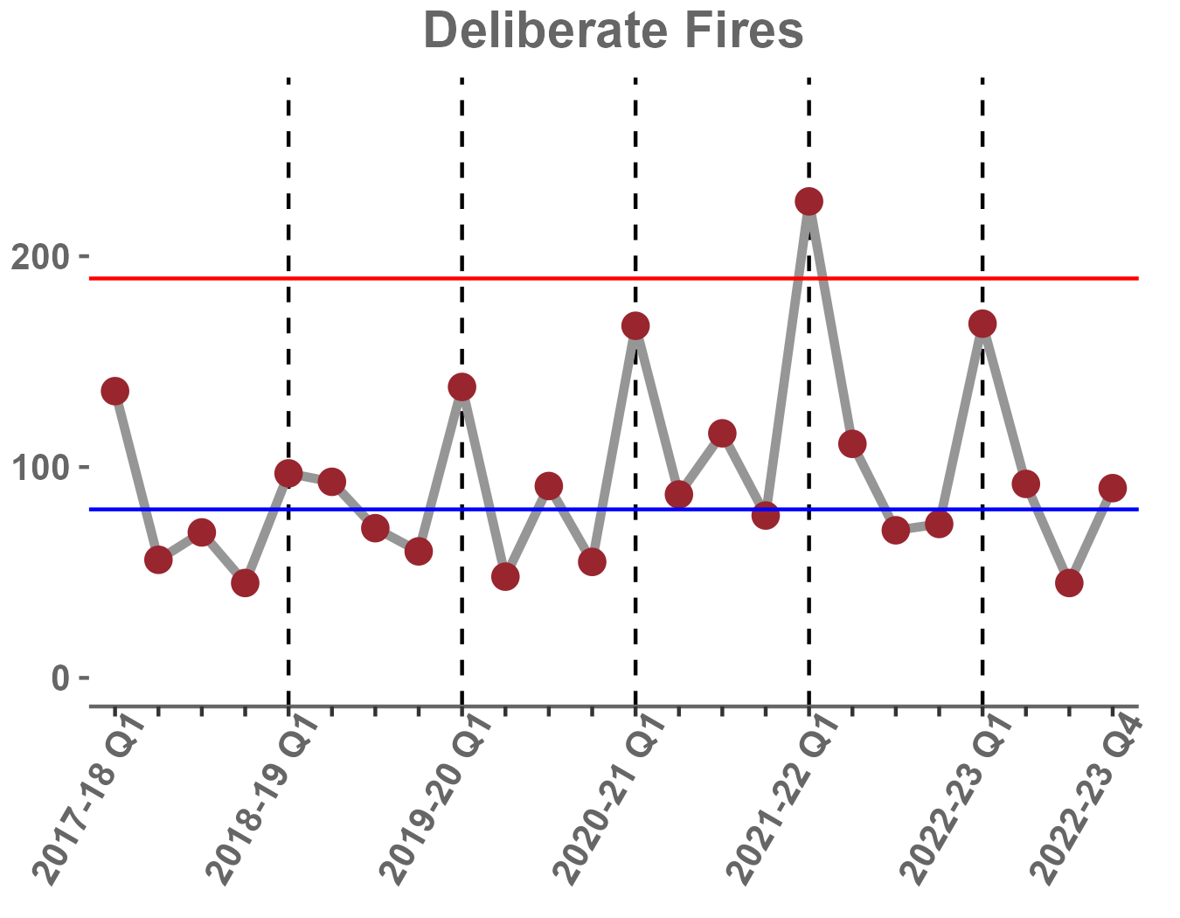

Deliberate fires have been subject to random variation since 2017-18 Q1. Figures in Q1 of each year appear to be higher than other quarters, with figures in Q1 being consistently above average each year and above the upper control limit in 2021-22 Q1. This is consistent with national patterns in the data.

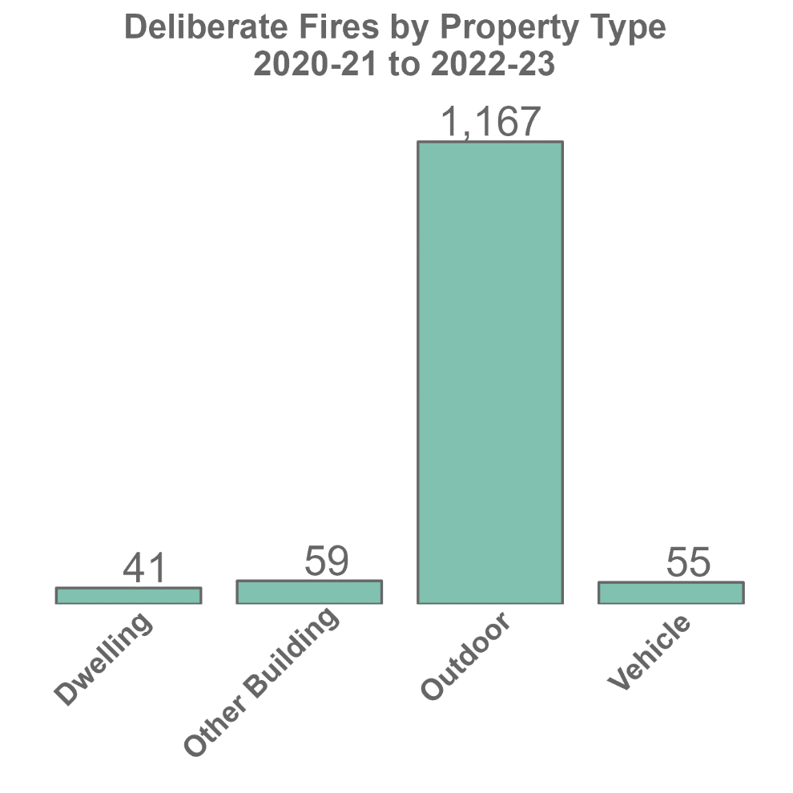

|  |
| --- |
| How we worked to improve our performance:  We sought to reduce the instances of fire related anti-social behaviour by:   * Identified parts of West Dunbartonshire communities affected by deliberate fire setting and shared this information with our partners at ASBTG. * Utilising our Youth Volunteer Scheme (YVS), Fire skills, Fire Safety Support & Education (FSSE) and school’s education programmes to raise awareness of the impact of fire related anti-social behaviour. * Working with partners to develop joint strategies to reduce the risk posed by deliberate fire setting and to mitigate its impacts.   We will monitor the effectiveness of reducing fire related anti-social behaviour by:   * Reviewing and reducing the number and type of deliberate fire setting incidents within West Dunbartonshire. * Evaluating the effectiveness of our Youth Engagement Programmes.   By achieving a reduction in fire related anti-social behaviour, we will:   * Enable the SFRS to divert resources towards other community-based activities. * Protect the natural and built environments. * Support the promotion of active and responsible citizenship across West Dunbartonshire communities. * Support our communities in feeling safe from crime, disorder, and danger |

**Environmental Health**

Environmental Health (EH) work closely with our partners and have membership to our Anti-Social behaviour Tasking group.

We have a statutory responsibility to investigate noise complaints under both the Environmental Protection Act 1990 (EPA) and the Anti-Social Behaviour etc (Scotland) Act 2004 (ASBA).

Although some noise issues can be identified clearly as either noise nuisances (EPA) or ASB noise (ASBA) there are also many which could fit both categories. Currently EH do not provide a routine out of hours service, so noise complaints are only attended within normal office hours, Monday-Friday, unless a specific case requires attendance at a different time.

Where noise complaints of an ASB type are received by EH they are normally signposted to both Police Scotland and WDC ASB Services who can provide a reactive response to noise issues when they are happening.

The nature of some noise issues being sporadic, intermittent, temporary means that sometimes the reactive services are unable to attend and witness the noise when it is happening. In these cases, either at the request of the affected individual or by referral from ASB Services, EH may install noise monitoring equipment in the affected property to enable measurements and recordings of the noise issues. Normally this is for a period of one week which is deemed sufficient to capture a representative account of the noise in question.

EH provide ASB Services with an acoustic report detailing any significant findings from the recording period and make available the audio recordings of the noise in question which may contain specific or additional elements of evidence, e.g., identifiable behaviours, threatening remarks etc. In all circumstances EH will assess the noise to see if it constitutes a nuisance under the EPA as this is a separate regime with different criteria from ASB noise. If statutory noise nuisance is identified, then EH will take their own enforcement action to ensure it is abated.

Another prominent noise complaint category is barking dogs. There is debate as to whether this can be categorised as ASB noise, but it can constitute a noise nuisance depending on the nature of it. Currently EH provide advice and guidance to the dog owners via the Dog Warden in an attempt to reduce the distress of the dogs and reduce the barking issue. Where this approach fails to work then EH will investigate so far as is practical to establish if a noise nuisance condition exists.

Statistics are provided below for the noise complaints received by EH during 2022 and 2023. Zero complaints were recorded as ASB noise dealt with under ASBA. This is not surprising as it is relatively rare to receive ASB noise complaints during the normal working day with the ASBA having higher noise tolerance levels for the daytime period compared with the evening or nighttime period.

As can be seen from the statistics, domestic noise issues, which are primarily ASB in nature, constitute approximately 50% of noise complaints received (excluding dog barking). Also, it can be seen that installing the noise monitoring equipment was primarily in response to ASB related noise.

**Noise statistics from 2022 and 2023**

Installation of noise monitoring Equipment

|  |  |  |
| --- | --- | --- |
| **Number of times installed** | **2022** | **2023** |
| In relation to ASB | 13 | 21 |
| Total | 18 | 25 |

**Noise complaints to EH.**

|  |  |  |
| --- | --- | --- |
| **Noise source** | **Complaints received 2022** | **Complaints received 2023** |
| Domestic noise (primarily associated with ASB) | 90 | 100 |
| Non-Domestic Noise (commercial, construction, entertainment) | 92 | 92 |
| Barking Dogs | 222 | 197 |

**Landlord Registration**

Landlord registration was introduced in 2006 by the Antisocial Behaviour etc. (Scotland) Act 2004. The Act introduced a registration scheme for local authorities to prepare and maintain a public register of all private landlords in their area. The regime has since been strengthened further by subsequent legislation. The powers available to local authorities through landlord registration have also been strengthened including powers to request a criminal record certificate in specified circumstances and to obtain information.

Whilst most landlords let their houses in a responsible way, some landlords continue to operate outside the law. Landlord registration, supported by other legislation, provides a means for local authorities to register persons who are fit and proper to act as landlords and agents, but also to take steps to deal with those who operate outside the law.

Whilst criminal landlords are in the minority, their illegal practices can have a disproportionate and devastating impact on communities and businesses across Scotland. Some criminality will be linked directly to the letting of houses, such as illegal evictions and operating as an unregistered landlord. In some cases, illegal landlord practice will be linked to other issues, such as providing illegal employment, benefit fraud, tax evasion, human trafficking, cannabis farms and money laundering. These are examples of material that is pertinent to the fit and proper person test.

* Number of Private Landlords Registered by EH:
* 2022/23 – 2445
* 2023/24 – 2198
* Number of complaints of ASB relating to private rented properties made to Environmental Health (All noise related)
* 2022/23 – 6
* 2023/24 – 5

**Use of Public Space CCTV**

West Dunbartonshire Council utilises in excess of 233 public space Closed Circuit Television units situated strategically around the council area. Their main purpose is to prevent crime by way of a visual deterrent; however, they also can be used to promote a sense of community safety and protect the vulnerable. Our CCTV Service is based within Clydebank Police Office, which enhances close working relations with Police Scotland, and all team members are highly trained in pertinent Data Protection Law and evidence review.

Studies have shown that CCTV, used in conjunction with other crime interventions and security measures, can be a redoubtable tool in the fight against crime, disorder and ASB. With this in mind, and where necessary, targeted surveillance of known anti-social behavioural Hot Spots can be deployed in line with the provisions of the Regulation of Investigatory Powers (Scotland) act 2000. Any associated evidence can thereafter be passed to our colleagues within the ASB Service to progress necessary investigations with a view to reducing offending behaviour (or progressing legal action).

Additional rapid deployment mobile units are also available to address transient or seasonal issues.

**Communities Team (Youth Diversity)**

Focussing on the PIER Model delivery, engagement and outreach work which encompasses youth diversity, provided crucial links to the prevention of ASB in West Dunbartonshire.

**Midnight League**

Midnight Football League is a Friday night diversionary activity open to young people between the age of 10 to 17 years, supported by the Communities Team and offered in partnership with WDLT. The project offers young people an opportunity to participate in positive activities as an alternative to hanging around the streets or engaging in risk taking behaviour on a Friday evening. The programme is predominately football based but young people have had access to arts sessions as well as issue-based support on alcohol and drugs.

Young people were identified during outreach sessions and signposted to the offer on a Friday evening.

Venue: Vale of Leven Academy, Alexandria. Times. 7pm till 9pm.

**Detached Youth Work**

West Dunbartonshire Youth Learning Team facilitate services to target young people in identified hotspot areas through outreach sessions. These hotspot areas are identified via the West Dunbartonshire Anti-Social Behaviour Task Force which includes representatives from Police Scotland, Scottish Fire and Rescue and Community based providers. The aim is to work with young people who are disengaged from any other provision available within the area. The programme aim is to then re-engage young people or refer them into existing youth work groups in their area such as the Midnight League provision.

**Summer Sessions**

West Dunbartonshire Youth Learning Summer Programme, known as “The Summer Sessions”, has been operational since 2017. During this time, it has supported young people from across West Dunbartonshire to participate in a wide range of exciting and fun activities, and informal learning opportunities. The programme has two aims;

* To provide young people with a wide range of creative and active opportunities to support personal and social development.
* To provide young people with access to free meals throughout the summer holidays, to combat holiday hunger.

The programme operates throughout the full duration of the school summer holiday period. It is open to young people from the age of ten to eighteen years and recruits one hundred and eighty participants annually, sixty each from Alexandria, Clydebank and Dumbarton.

**Greenspace (Graffiti Removal)**

The below services are delivered focussing on three main parts which promote the strategy in terms of Education, Enforcement, Awareness. Whilst enforcement is always the last available option, focus is given to educational programmes within the local authority. These programmes cover all seven primary schools, and we also engage with the Experiential Learning Project in which again is delivered to all primary 7 pupils reaching over 1000 in nine days across the authority.

With view on awareness, we will engage with communities and take part in local public information events in which we provide information and literature on the services available and how we can work together.

Graffiti stats-

* 2021/22 = 202 reports and removals
* 2022/23 = 146 reports and removals
* 2023/24 = 91 reports and removals

Generic graffiti requires removal within 5 days and offensive graffiti requires removal within 24hrs. There has been a significant decrease of offensive graffiti instances and removals over the last 3-5 years.

**Education Services**

West Dunbartonshire Council Education Service believe its aim is to help develop children and young people who are successful learners, confident individuals, effective contributors and responsible citizens. Education plays an important role in the prevention of the various types of anti-social behaviour from occurring in the first place. We believe that young people are entitled to live safely without fear of harassment and nuisance and that the greater awareness young people and children have of the issues the more likely we are to bring about a change in attitude and behaviours.

**Education and Awareness**

As part of our curriculum programme schools cover the topic of Crime and Law is covered at various ages and stages within the school curriculum. Looking at impact and consequences of anti-social behaviour and detailing the role of the police, courts and other groups in supporting and tackling it. Within our Personal, Social and Health Education programme young people cover various related topics as substance misuse. We also hold frequent assemblies to discuss how we can support and contribute to our local community; we invite special guest speakers from Police Scotland and the Scottish Fire and Rescue Service to present on issues around Fire Setting and Anti-Social behaviour. All young people take part in the Youth Philanthropy Initiative which teaches our young people about the importance of contributing to their local community.

**Promotion of Positive Behaviour**

Schools aim to foster a positive culture through initiatives such as peer mentoring, promoting and rewarding good behaviour and respecting equality and diversity.

**Early Intervention**

Schools work closely with partner agencies such as Counselling Services, Social Work, SACRO, SCRA, Youth Engagement Officers and Includem to identify and work with young people who are on the cusp of offending in their community and those displaying signs of anti-social behaviour to support these young people move away from these behaviours and attitudes.

**Criminal Justice**

The remit of West Dunbartonshire’s Community Justice Partnership is to prevent and reduce further offending by addressing its underlying causes. The partnership is the strategic mechanism where partners collaborate to safely and effectively manage and support those who have come into conflict with the law, helping them to fully integrate into their community and realise their potential for the benefit of all citizens. The partnership prioritises the safeguarding of victims ensuring they are afforded protection and supported in their recovery from the impact of crimes committed against them.

This collective, trauma informed approach to Justice, minimise the harm caused by drugs, homelessness and poverty (and its related consequences to the person, family and the wider community) has the potential to transform lives and reduce offending which in turn transforms communities.

This collaborative response to local Justice is underpinned by priorities identified in “Vision for Justice in Scotland (2022)”; “The National Strategy for Community Justice (revised 2022)”; “The Community Justice (Scotland) Act 2016; and West Dunbartonshire Community Planning Local Outcome Improvement Plan 2017 – 2027.

A legal definition of ‘Community Justice’ is provided in section 1 of the Community Justice (Scotland) Act 2016 (the Act). Research offered in the “Vision for Justice in Scotland (2022)” publication helps us to better understand the trajectories of those who enter into justice systems. The evidence appraises the intersectionality of offending behaviours with poverty; homelessness; substance misuse; physical and mental health inequalities; Adverse Childhood Experiences (ACEs); Sex; and the impact of Trauma – providing greater understanding into what drives and shapes offending behaviour and perpetuates recidivism. By tackling the root causes of offending to reduce recidivism victims are fewer and communities are safer.

Evidence shows that sentences served in the community have better outcomes for those involved in justice systems creating real and meaningful opportunity for behaviour change, personal growth, along with space and time for recovery from their own experiences of trauma that are directly linked to patterns of offending. A community-based approach to justice offers a balanced, proportionate and thoughtful response to people who pose little or no risk to others in their communities.

“Community sentences are often more effective at reducing reoffending and less costly than prison sentences, particularly when it comes to sentences of under a year. Of those released from prison in 2017/18 who had served a sentence of a year or less, 49% were reconvicted within a year. The average prisoner place costs £37,334 per year, compared to £1,894 for a Community Payback Order.” (Source: Scottish Government, cost of the criminal justice system in Scotland dataset (2016/17)).

“Scotland’s communities have benefitted from around 10 million hours of unpaid work carried out by people serving community sentences since 2011.” (Source: Justice Social Work Statistics in Scotland: up to end of year 2021-22).

# Consultation

As part of the consultation process, all residents were invited to take part in the 2023 ASB survey asking them to tell us what they wanted us to prioritise and what they felt were the main anti-social issues for them; 246 people responded to the survey. In addition, focus groups were held with the west Dunbartonshire Tenant Resident Organisation, Age Concern and the West Dunbartonshire Equalities Forum.

The main findings from the survey are as below:-

ASB Survey 2023

|  |  |  |  |
| --- | --- | --- | --- |
| **Experience of ASB** | Major problem | Minor problem | Not a problem |
| Alcohol related ASB | 27.24% | 28.86% | 43.9% |
| Antisocial driving/speeding | 44.72% | 39.02% | 16.26% |
| Arson/fire raising | 10.57% | 27.24% | 62.2% |
| Dog fouling/inconsiderate dog ownership | 56.5% | 28.66% | 14.63% |
| Domestic noise nuisance | 27.24% | 28.86% | 43.9% |
| Environmental ASB (graffiti, littering etc) | 41.05% | 34.15% | 24.8% |
| Groups of people hanging around | 33.33% | 34.15% | 32.52% |
| Hate incidents | 7.72% | 19.92% | 72.36% |
| Neighbour disputes | 17.48% | 26.83% | 55.69% |
| Drug related ASB | 43.5% | 17.48% | 39.02% |
| Vandalism | 29.67% | 34.15% | 36.18% |

|  |  |  |  |
| --- | --- | --- | --- |
| **Hate incidents against…** | Major problem | Minor problem | Not a problem |
| Disabled people | 11.48% | 14.75% | 73.77% |
| Transgender people | - | - | 100% |
| Gay/lesbian/bisexual people | 25% | 10% | 65% |
| BME people (0.81% of survey) | 50% | - | 50% |

|  |  |  |  |  |
| --- | --- | --- | --- | --- |
| **Experience of ASB time of day** | Evening | Daytime | All times | Not a problem |
| Alcohol related ASB | 45.53% | 2.85% | 32.11% | 19.15% |
| Antisocial driving/speeding | 23.58% | 4.88% | 53.66% | 17.89% |
| Arson/fire raising | 23.58% | 1.22% | 7.32% | 67.89% |
| Dog fouling/inconsiderate dog ownership | 2.44% | 3.25% | 78.46% | 15.85% |
| Domestic noise nuisance | 23.58% | 4.88% | 53.66% | 17.89% |
| Environmental ASB (graffiti, littering etc) | 10.98% | 2.03% | 56.91% | 30.08% |
| Groups of people hanging around | 38.62% | 1.63% | 23.98% | 35.77% |
| Hate incidents | 0.81% | 1.63% | 13.82% | 83.74% |
| Neighbour disputes | 6.91% | 0.41% | 29.27% | 63.41% |
| Vandalism | 17.07% | 0.81% | 38.62% | 43.5% |

|  |  |  |  |  |
| --- | --- | --- | --- | --- |
| **Experience of ASB day of the week** | Everyday | Weekends | Weekdays | Not a problem |
| Alcohol related ASB | 31.3% | 13.41% | 1.63% | 53.66% |
| Antisocial driving/speeding | 70.33% | 11.38% | 1.22% | 17.07% |
| Arson/fire raising | 13.41% | 13.41% | 1.22% | 71.95% |
| Dog fouling/inconsiderate dog ownership | 81.33% | 0.41% | 1.22% | 17.07% |
| Domestic noise nuisance | 31.3% | 13.41% | 1.63% | 53.66% |
| Environmental ASB (graffiti, littering etc) | 58.94% | 6.1% | 3.25% | 31.71% |
| Groups of people hanging around | 31.71% | 30.49% | 1.63% | 36.18% |
| Hate incidents | 13.41% | 1.63% | 1.22% | 83.74% |
| Neighbour disputes | 25.61% | 7.32% | 3.25% | 63.82% |
| People using or dealing drugs | 55.28% | 3.66% | 0.81% | 20.24% |
| Vandalism | 35.77% | 15.85% | 1.22% | 47.15% |

|  |  |  |  |  |  |  |
| --- | --- | --- | --- | --- | --- | --- |
| **Experience of ASB time of year** | Spring | Summer | Autumn | Winter | All year round | Not a problem |
| Alcohol related ASB | 0.41% | 17.48% | 0% | 0% | 63.41% | 18.7% |
| Antisocial driving/speeding | 0% | 5.28% | 0% | 0.41% | 41.06% | 53.25% |
| Arson/fire raising | 0% | 8.13% | 1.22% | 1.63% | 20.73% | 68.29% |
| Dog fouling/inconsiderate dog ownership | 0% | 0% | 0% | 0.41% | 82.52% | 17.07% |
| Domestic noise nuisance | 0% | 5.28% | 0% | 0.41% | 41.06% | 53.25% |
| Environmental ASB (graffiti, littering etc) | 0% | 4.07% | 0% | 0.41% | 66.26% | 29.27% |
| Groups of people hanging around | 0% | 16.26% | 0% | 0% | 50% | 33.74% |
| Hate incidents | 0% | 0.81% | 0% | 0% | 15.85% | 83.33% |
| Neighbour disputes | 0% | 2.03% | 0% | 0.41% | 34.15% | 63.41% |
| People using or dealing drugs | 0% | 1.63% | 0% | 0% | 58.54% | 39.84% |
| Vandalism | 0% | 4.88% | 0% | 0% | 49.59% | 45.53% |

|  |  |
| --- | --- |
| **Are any of the behaviours you have commented on predominantly youth related?** | |
| Yes – some of them | 60.16% |
| Yes - all of them | 10.98% |
| No | 21.95% |
| Don’t know | 6.91& |

|  |  |
| --- | --- |
| **Have you lived in your local area for longer than a year?** | |
| Yes | 97.56% |
| No | 2.44% |

|  |  |
| --- | --- |
| **If you reported ASB in the last year how satisfied were you with the response?** | |
| Very satisfied | 1.63% |
| Satisfied | 1.22% |
| Neither | 13.01% |
| Dissatisfied | 15.04% |
| Very dissatisfied | 18.29% |
| n/a | 50.81% |

|  |  |
| --- | --- |
| **Thinking about ASB as a whole, is your local area a better place to live in now?** | |
| No change | 56.1% |
| Worse | 38.21% |
| Better | 3.25% |

# 

# Communication

Information Sharing Section 139 of the Antisocial Behaviour etc. (Scotland) Act contains provisions that allow agencies involved in tackling anti-social behaviour to share relevant information. There are several relevant information sharing protocols as well as meeting forums where relevant information can be shared.

When considering whether to share information, the issue of public interest needs to be balanced against the individuals’ rights. By doing so we will consider:

* Is there an overriding need to prevent crime, disorder, or other public safety threats?
* Is it necessary to protect vulnerable people?
* Is there another way of tackling the problem?
* Is the sharing of information proportionate to the intended aim?

Communication plays a major part in reassuring communities that efforts are being made to tackle anti-social behaviour. To help build public confidence and to ensure that the public are aware of local initiatives to tackle anti-social behaviour we will:

* Raise awareness of anti-social behaviour through use of social media.
* Provide information on good practice initiatives to prevent and tackle anti-social behaviour.
* Encourage people to report incidents of anti-social behaviour by improving access to services.
* Publicise good news stories and successes in tackling anti-social behaviour.
* Publish information leaflets detailing service provision and contact details.

Additionally, progress reports will be submitted to the Scottish Housing Regulator and regular updates will be provided to tenants and residents groups.

# Performance Monitoring

To ensure we monitor these outcomes, ASB is governed by the West Dunbartonshire Community Planning Safe Delivery Improvement Group (DIG), Anti-Social Behaviour Tasking Group and Scottish Government, Annual Returns Charter (ARC)

Argyll & West Dunbartonshire Police work collaboratively with West Dunbartonshire Council, SFRS and other partner agencies as required to ensure ASB across the locality is addressed in an efficient, effective, legal, and proportionate manner to protect the residents and visitors to the area.

This partnership approach is fluid, and relevant partners will meet monthly to identify problematic areas, trends or seasonal issues which allows for a partnership approach to counter any issues raised. Monthly meetings allow for issues to be identified and addressed prior to escalation and in doing so minimising the impact of such behaviours on the community.

The group will utilise partnership monthly performance data to identify ASB trends to best deploy resources. Performance Data and the WD ASB Strategy will be utilised to ensure partners are addressing the issues having the greatest impact of residents.

We will be successful if the following are achieved:

* **A more pleasant street environment.**
* **Residents feel safer in their neighbourhoods.**
* **A reduction in the number of neighbour complaints.**
* **Meaningful engagement with residents, and reassurance that the Council and Police take complaints seriously is recognised as core.**
* **We will ensure that resident communications needs are meet.**

The strategy is a three-year document, performance against the outcomes will be reviewed and reported annually. We will establish targets and ensure resources are targeted appropriately. In delivering this strategy, we are committed to:

* + Ensuring an appropriate response to the victims of ASB.
  + Adopting a victim centred approach in delivering services which ensure a fast and effective response to ASB.
  + Challenging our partners to respond to the preventative agenda relating to ASB.
  + Developing a media strategy to communicate a “Zero Tolerance” message.
  + Providing information to the public on our progress in this area.
  + Reviewing our procedures regularly.
  + Reviewing staff training to ensure that relevant staff are trained to address ASB.

**Publication**

**This document is also available in other languages, large print and audio format on request.**

**Gaelic**

Tha an sgrìobhainn seo cuideachd ri fhaighinn ann an cànanan eile, ann an clò mòr, agus ann an cruth claisneachd ma thèid iarraidh

**Arabic**



**Hindi**



**Punjabi**

**Urdu**

**Chinese (Cantonese)**

**Polish**



**Ukrainian**

Цей документ також доступний іншими мовами, великим шрифтом та в аудіоформаті за запитом.

West Dunbartonshire Council, 16 Church Street, Dumbarton G82 1QL

For any relating to the strategy please contact Scott Mclelland

[Scott.mclelland@west-dunbarton.gov.uk](mailto:Scott.mclelland@west-dunbarton.gov.uk)